**Algorithms:**

This assignment’s objective is to set up as well as maintain a distributed file system. It utilizes a single File server that is the center process which handles all file requests from any number of clients. Files are cached on both the client as well as the server side.

*FileClient.java*

For our program, the File Client will ask the user for a filename as well as access mode. This information that was provided is used to access as well as download a file from the File Server. The File Client in our program can only have a singular file opened at one instance. If the File Client is the owner of this file, then the File Client has to writeback to the server by uploading this file. A file that is accessed for the “write” option is considered to be modified and a write back will be required.

As the File Client maintains its own cache, it always caches the latest file that was opened by a user since the start of the application. It is maintained in the following states: Invalid, where the cache doesn’t have a copy of the file that can be read or written, Read_Shared, the current file that is available to be read, Write_Owned where the current file is owned by the File Client for writing, Modified_Owned where the current file is owned for writing and there have been changes that have been recently written to it, and finally Release_Ownership, where the current file is being edited and must be written back as soon as it can.

The writeback specification is handled to by the state modified_owned. A client could receive a writeback signal from the server at two different points: if the file is being edited as well as after the file is edited, but with the condition of before a new file is opened. In the first cases described, we really only want to write back when the editor is closed, so that we can transition to the release_ownership state. In the second case, we would want to write back right after since the user is not actively using the file. If the file was still in write_owned, the file would be uploaded when the instances occurs where the user switches files. Thus, the file that is put into the modified write_owned state, on writeback changes will upload immediately and transition to read_shared. If the same file is opened again for write, it goes back to write_owned.

A Client will handle two calls from the server: invalidate and writeback. Invalidate will set the state to invalid and is only called if the File Client is registered to read. Writeback will either write back immediately or sets the File Client to writeback as soon as the current session of editing is complete.

Lastly but not least, due to how the serer works, when a client opens a file for write and another client owns the file for write, the current client will wait until the other client’s editing session closes.

*FileServer.java*

For the File Server part of our program, it essentially acts as a provider of the files to the File Clients. The server uses a Vector for caching to maintain a list of files. All entries in the File Server are used to track down readers for invalidations and for identifying the “write-owner” of a given file. The File Server uses synchronization in order to support a thread to wait for the client to finish writing as well as uploading the file back to the server.

The server maintains the file system which contains all the files that the client desires to access. The server caches all the files that were opened during the course of execution. The server will respond to client with the two following functions: download and upload. When downloading, the File Server will get a file, and if the file is not cached yet, then it will be cached. When uploading, it means it will upload the latest written contents, the client will release write ownership as well as invalidate all readers.

As of right now, the server will use a write-through policy for all cached files. Changes to this cache are written back to the file on the upload function. This will happen at this own time, within its own thread. There are three different states for the cached file: NOT_SHARED, READ_SHARED, and WRITE_OWNED. NOT_SHARED is when no client is reading or writing to the file, and when the owner is null and when the readers are empty. READ_SHARED is when one or more clients are reading and writing to the same file, the owner is null, and the readers are not empty. WRITE_OWNED is when a client is writing to the file, many clients can be reading the file, the owner is not null, and the reader state does not really matter.

**Discussion:**

*Functional Improvement*

One functional improvement that can be made is that the files can only be accessed by emacs. If there was support for more applications that were not just Emacs, this could greatly extent the functionality of the program.

Another one is that the client really does not have any idea which files are currently available in the server. If we were to implement a command that is similar to the ls command on an ftp application, that could be very useful for the clients to know what files can be used from the server rather than just doing it based off our own memory.

This distributed file system could also be enhanced by implementing a graphical user interface. This would essentially separate the model, view and controller of the application; Thus we could allow other application users to access files with more ease. Also, we would not have to do work to print messages in the terminal while ensuring that the interface prompts are properly given to the user.

Having an implementation for multiple sessions would also greatly improve functionality, currently we can only allow a client to access one file at a time, this limits the user for reading and writing multiple files which could be a very useful function.

Reliability is also a huge factor that could be improved, and our DFS currently does not have ways to backup data, so the server is mostly vulnerable to clients who could potentially corrupt files and write them back to the server. The server could theoretically setup checkpoints where files are constantly backed up.

Lastly one thing to be improved on is that we could introduce a hierarchical directory system for this DFS. Right now, all the files in the server are just automatically assumed to be in the local directory of all the source files and class files. This could be very disorganizing and could case the clients to touch restricted files (such as the source and class files).

*Performance Improvement*

Currently our program can only support the utilization of one single server. The server is a hotspot for many clients and could cause a bottleneck when too many requests are made. Continuing on that last point, the server could crash and then it will leave all the clients without access to other files. Fault-tolerance should be introduced, something like server replication that can mitigate congestions or crashes to continue providing service to all the clients.

In order to reduce the communication overhead that is created between the server and the clients, the clients should be able to cache multiple read-shared files rather than just having one single file in the cache. This can improve performance and reduce the network congestion due to the localness of the files in the clients.

Lastly an improvement that can be made to improve performance that also relates to one of the functional improvements we have suggested, is that Emacs is a very slow file editor. Opening files using emacs is extremely slow and sometimes even incompatible with other applications that use remote login. It makes some sense that we use Emacs to provide a good demonstration of the project, but if we were to use VIM (or allow both) to access the files, performance would be greatly improved.

**Execution Outputs:**

Step 1: Open 4 windows: cssmpi1, cssmpi2, cssmpi4, and cssmpi8.

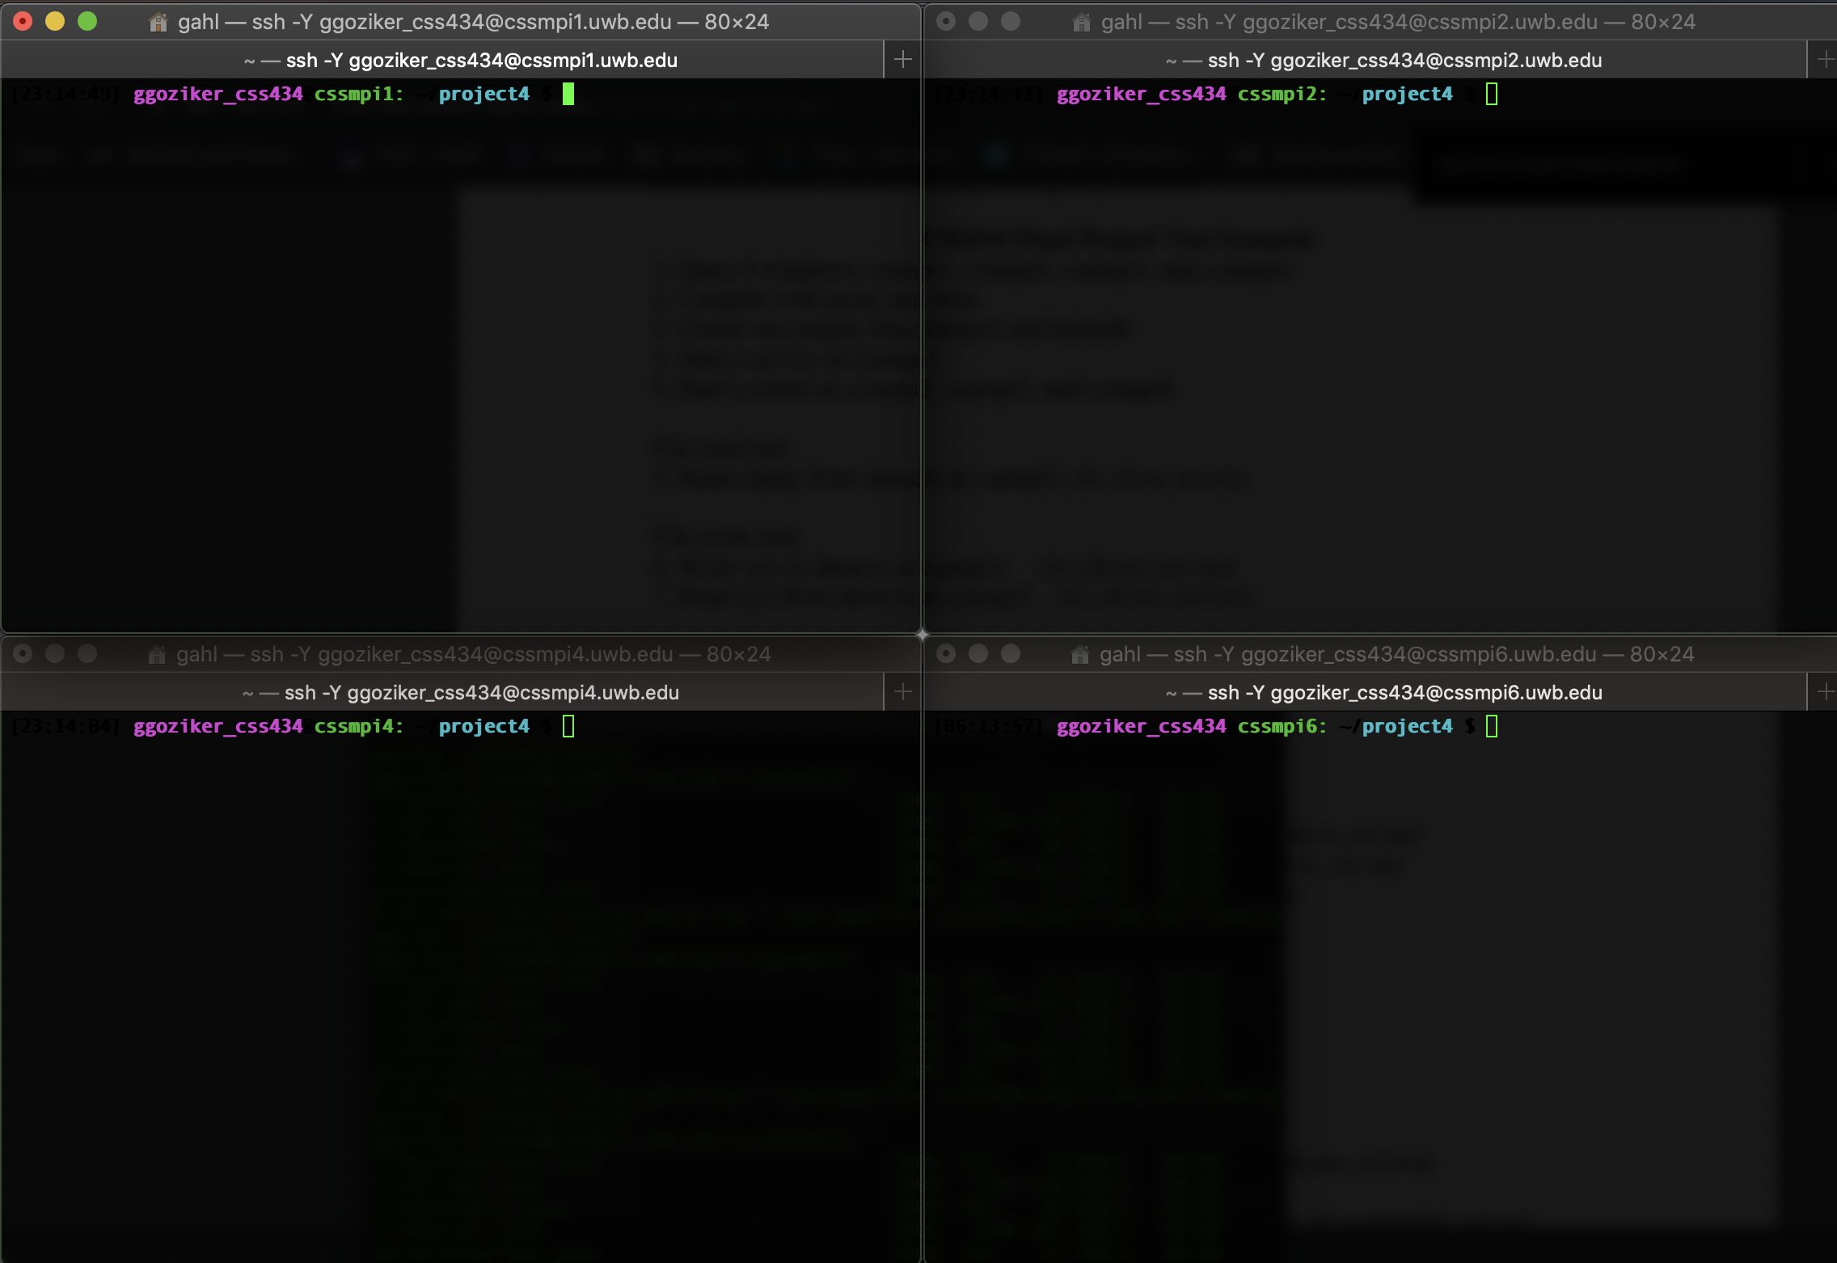

Step 2: Compile with javac and rmic.

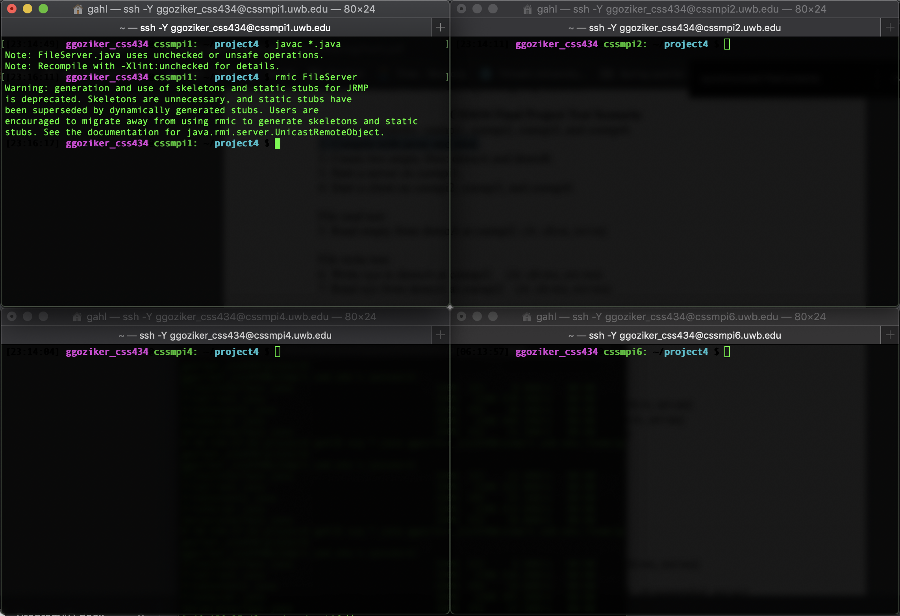

Step 3: Create two empty files: demoA and demoB. Start a server on cssmpi1.

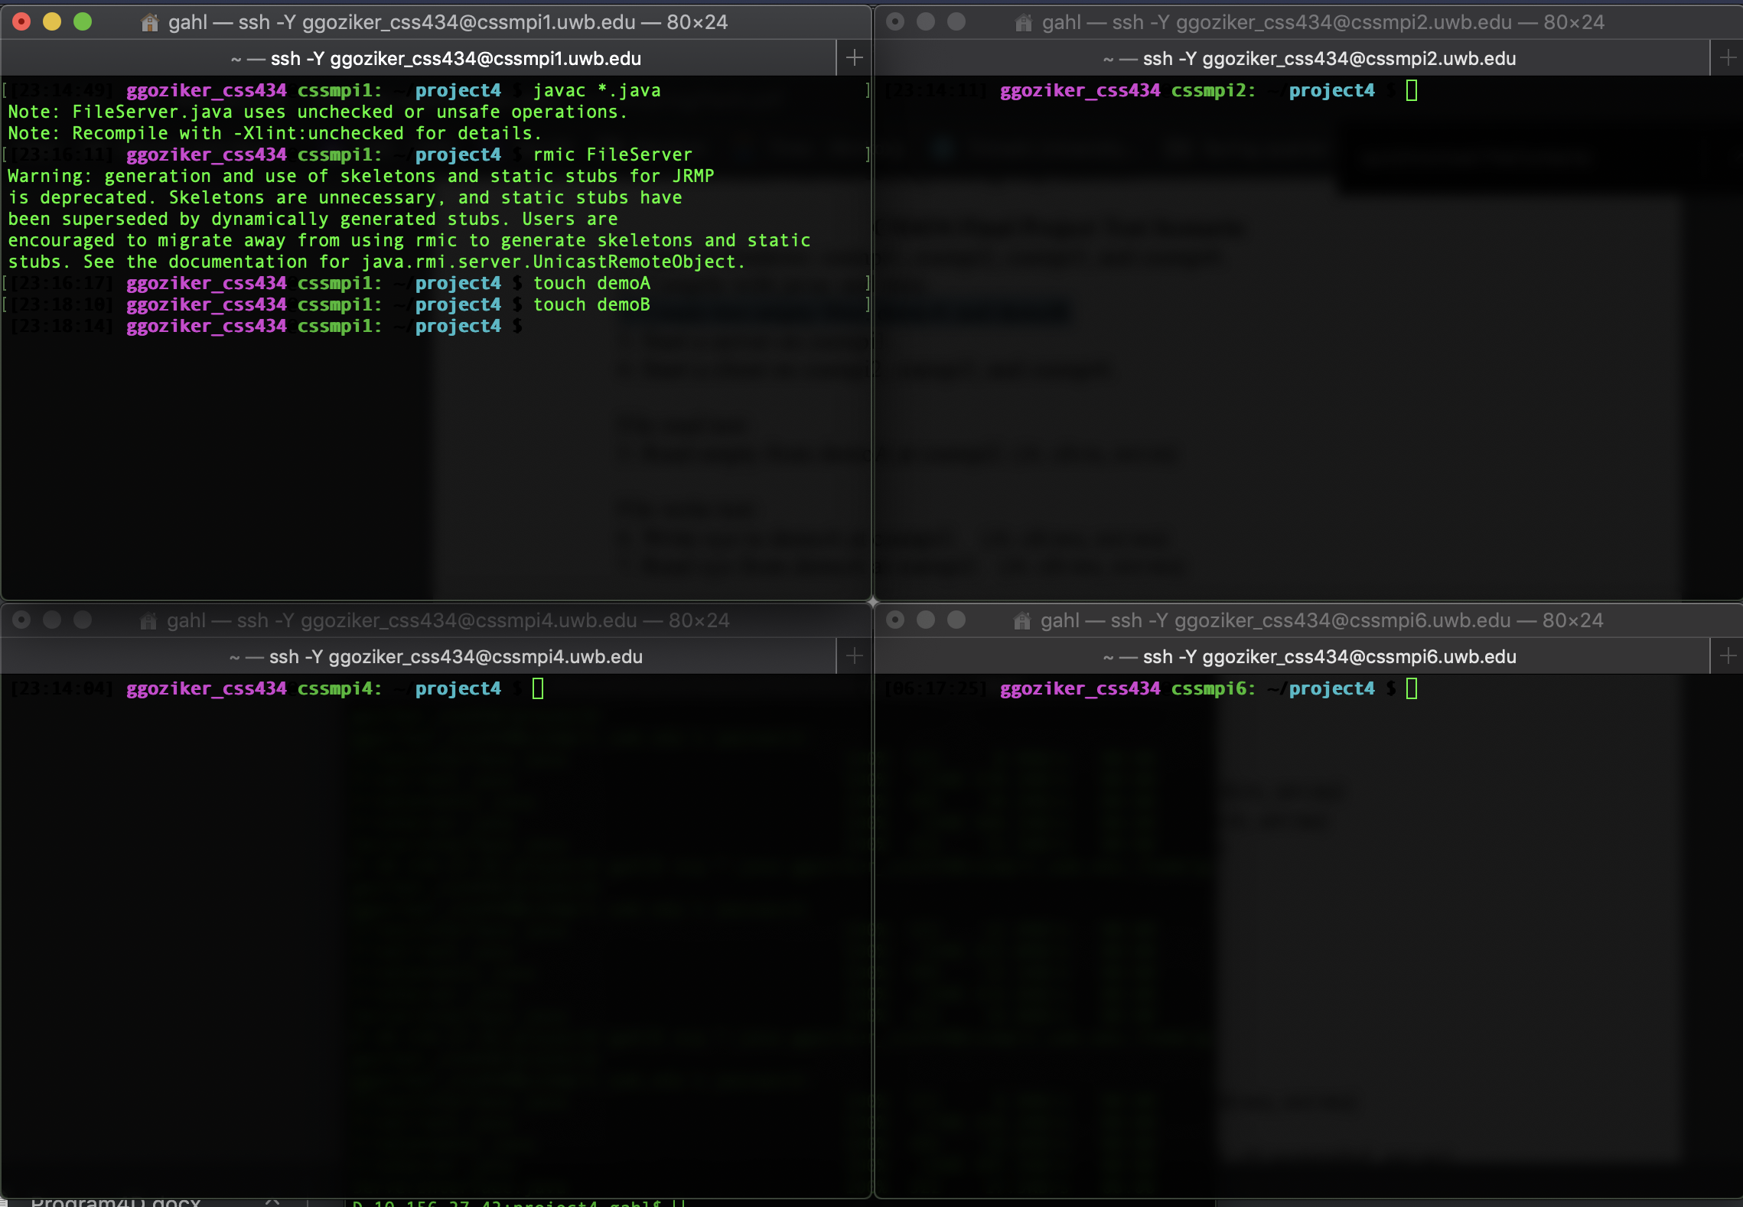

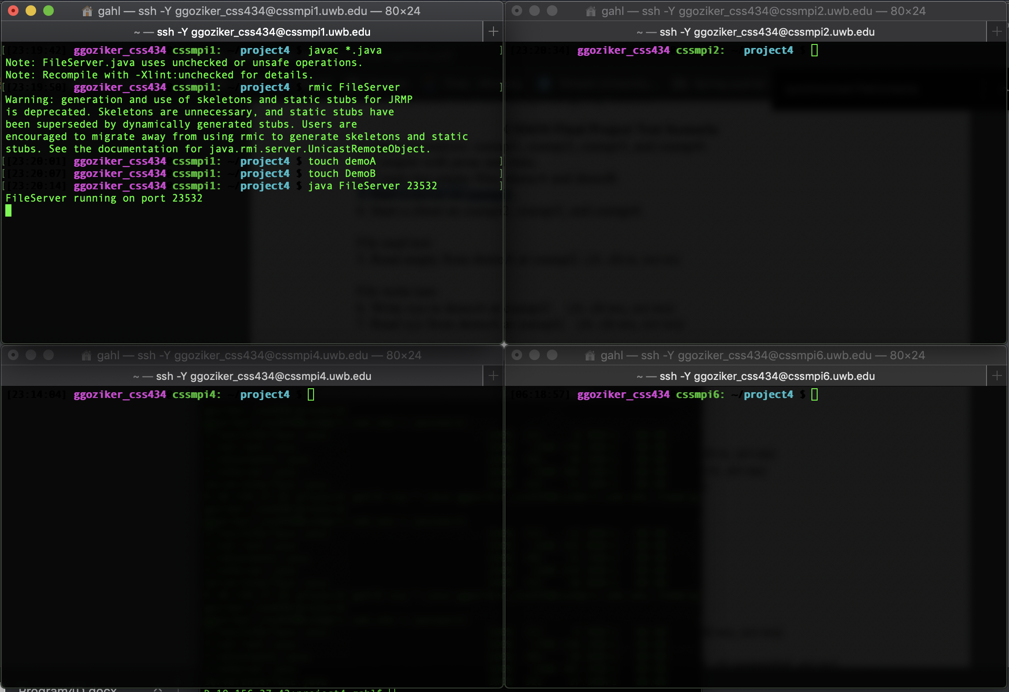

Step 4: Start a client on cssmpi2, cssmpi4, and cssmpi8.

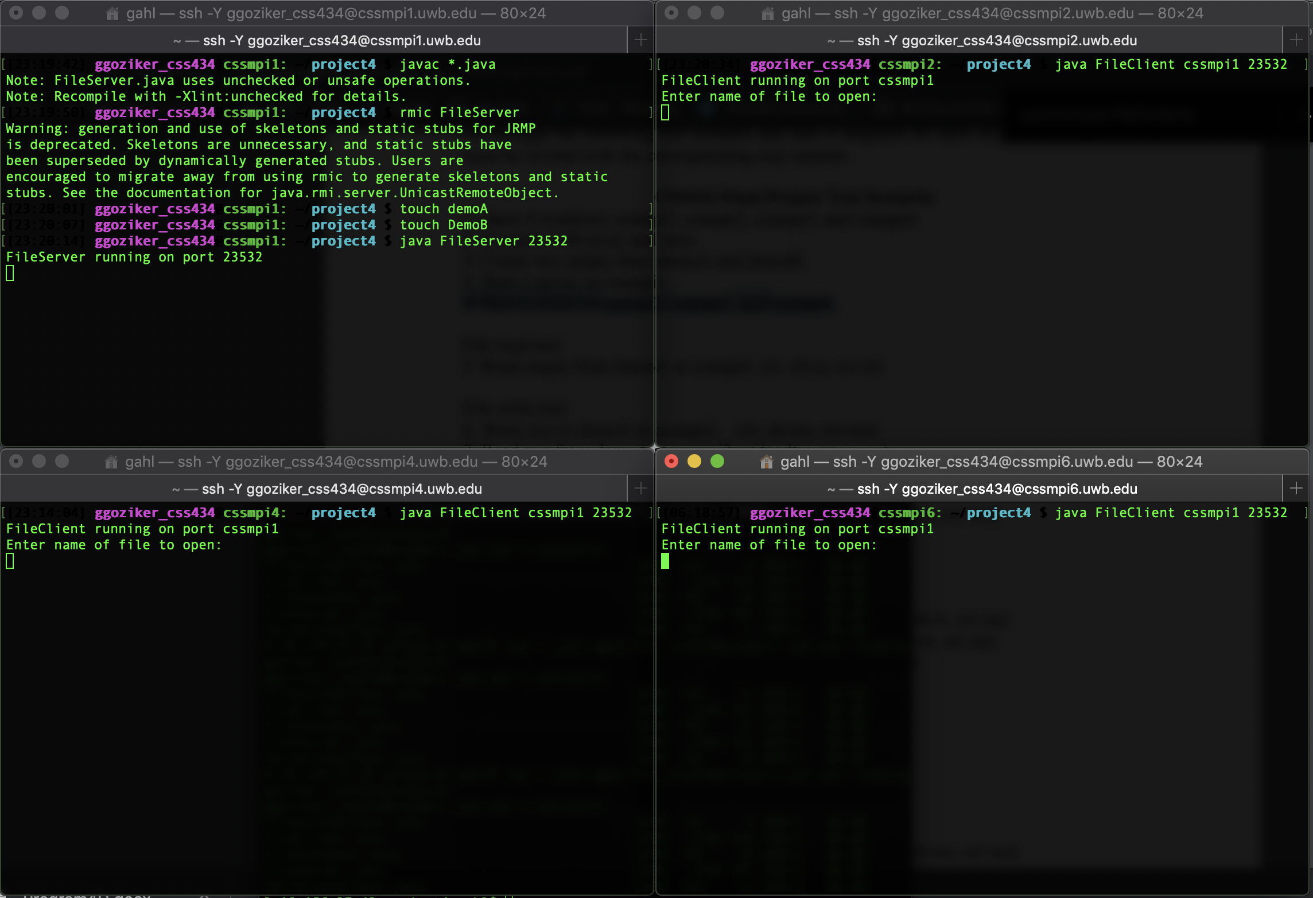

Step 5: Read empty from demoA at cssmpi2. (A: clt:rs, svr:rs)

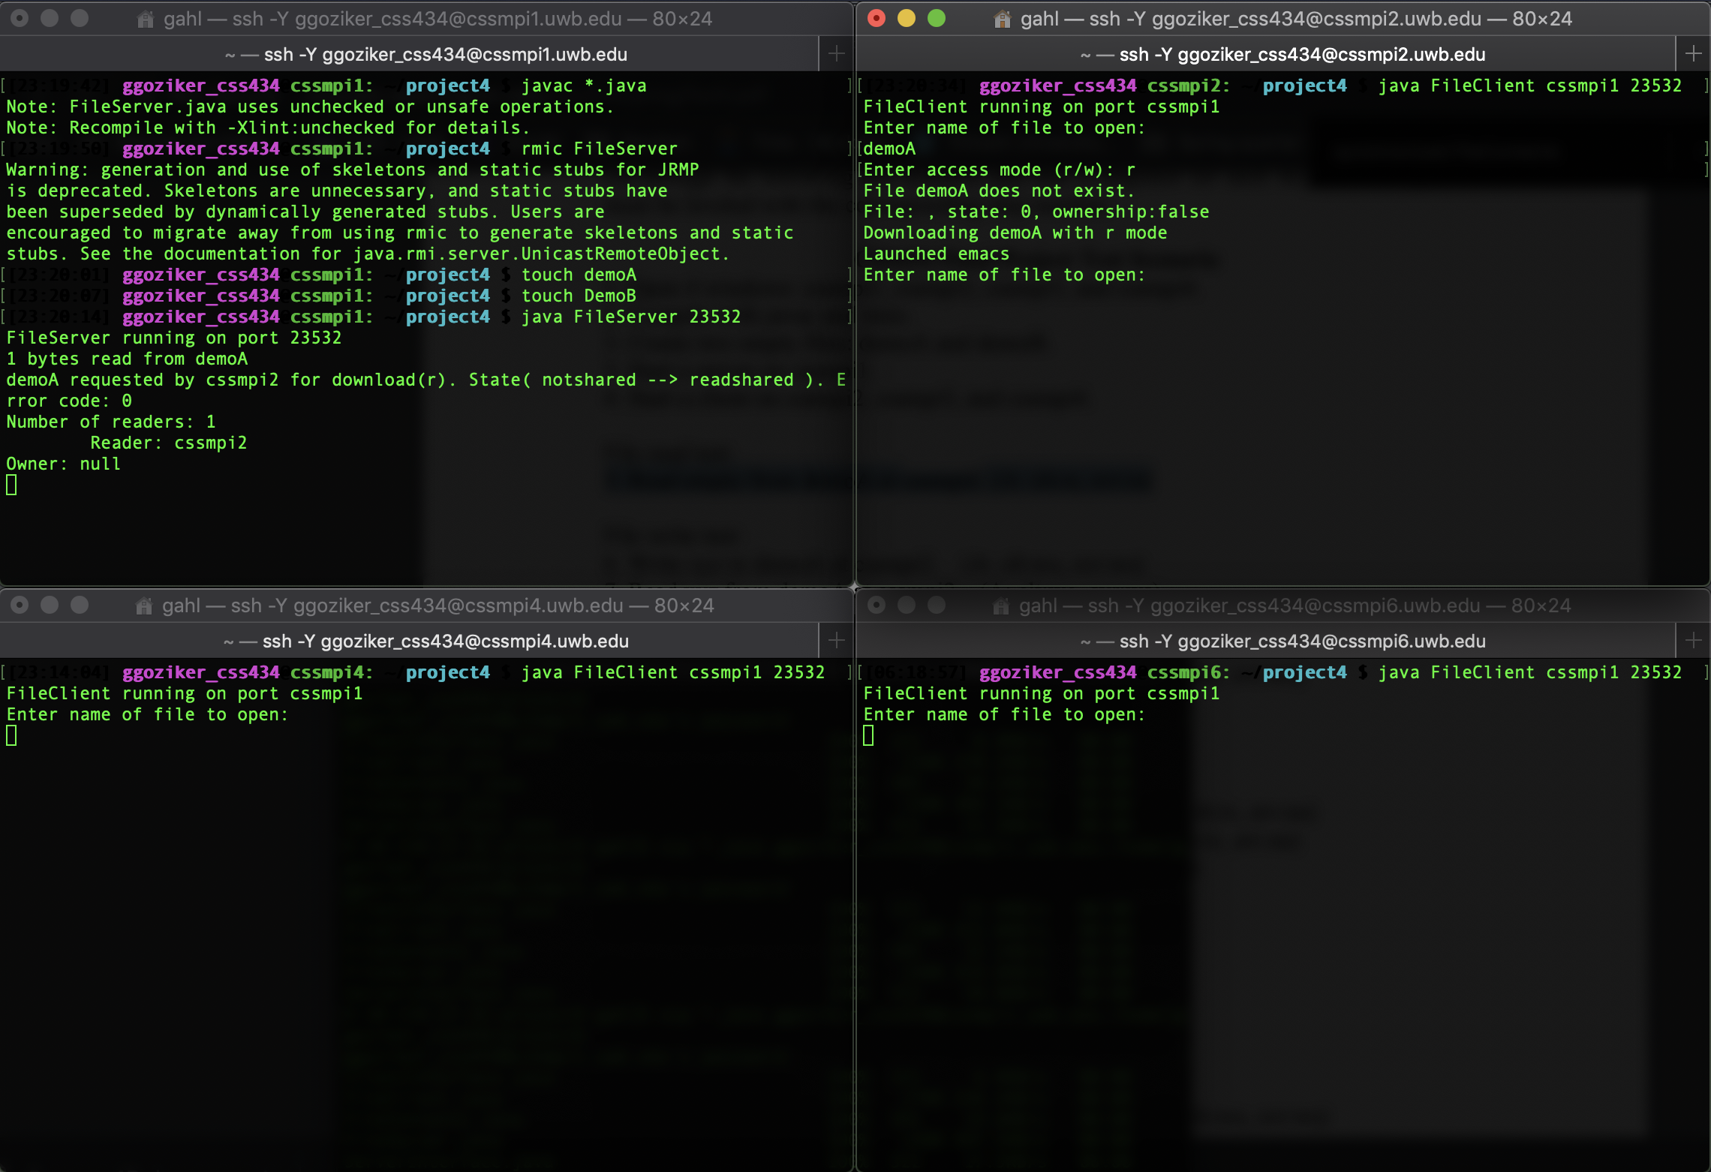

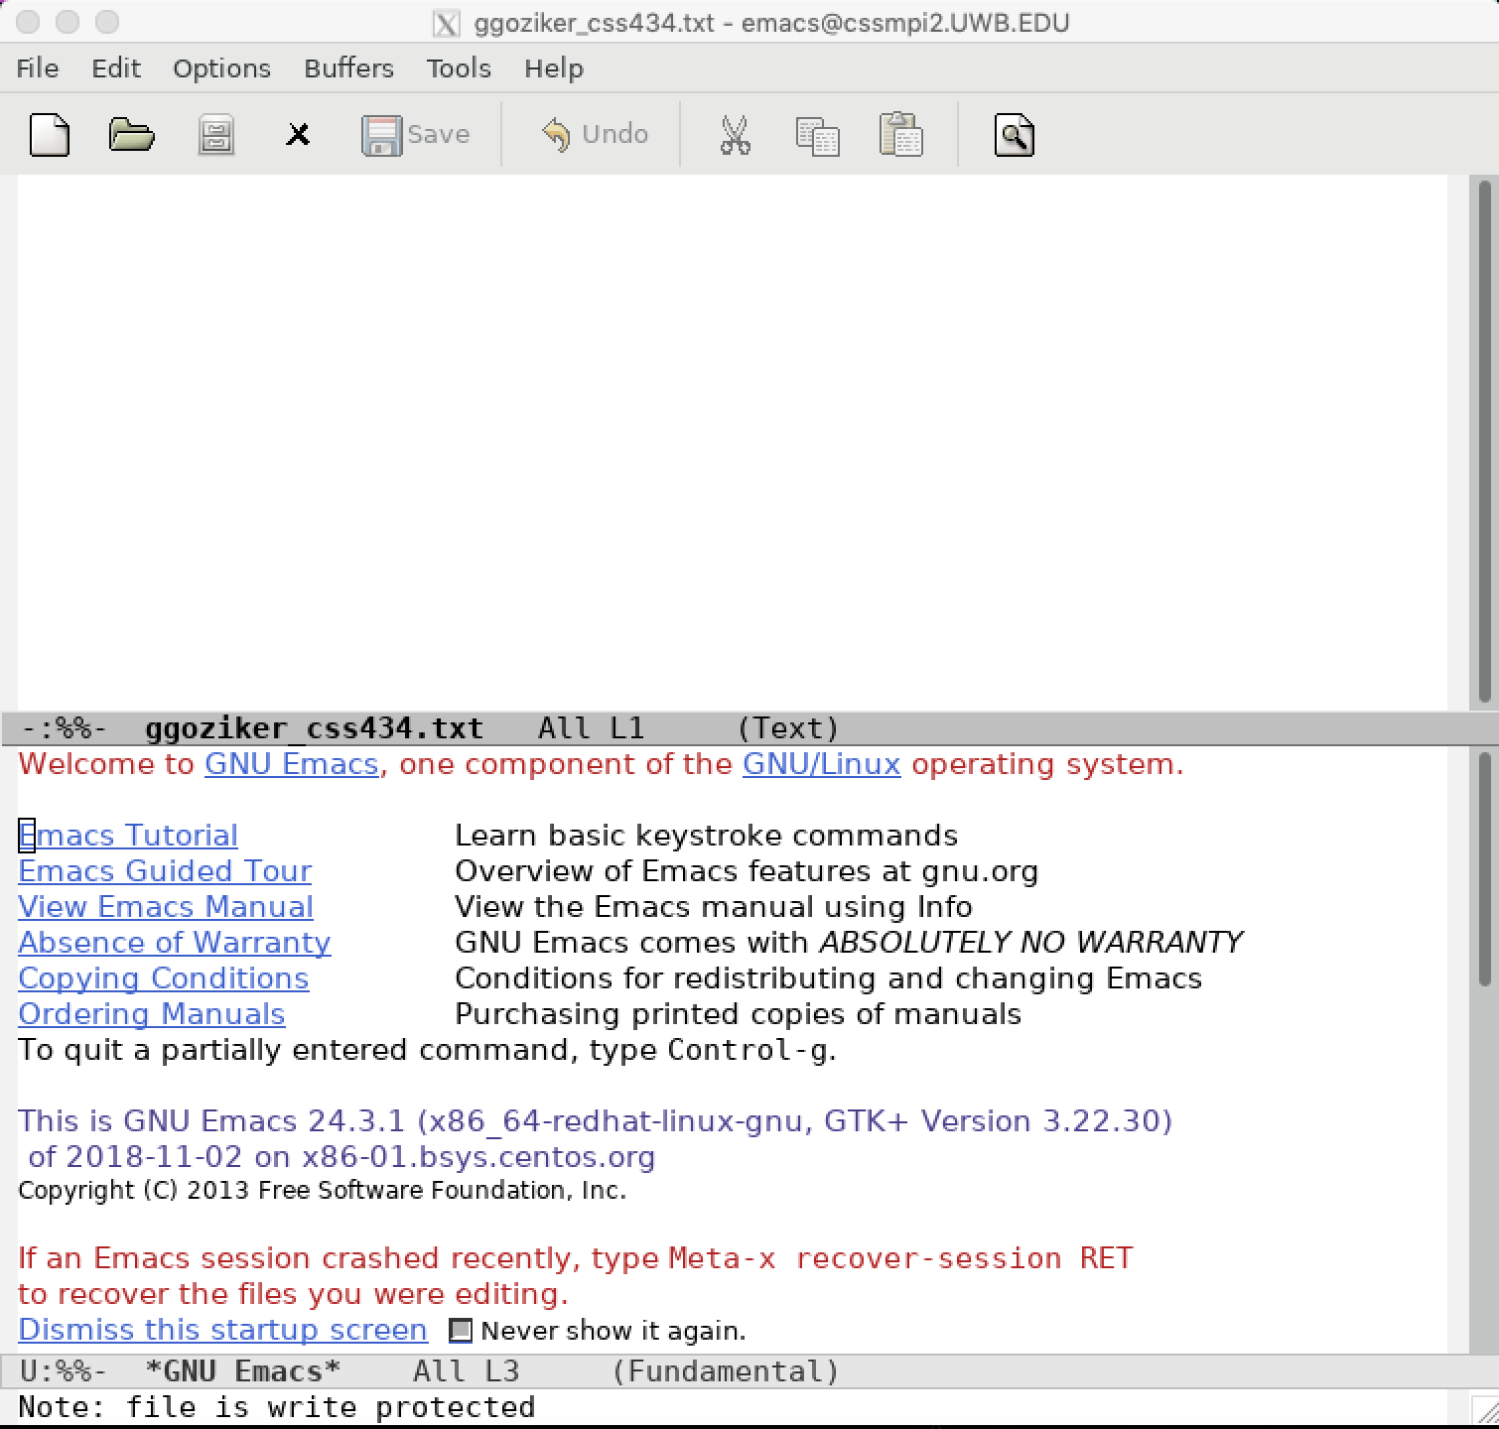

Step 6: Write xyz to demoA at cssmpi2. (A: clt:wo, svr:ws)

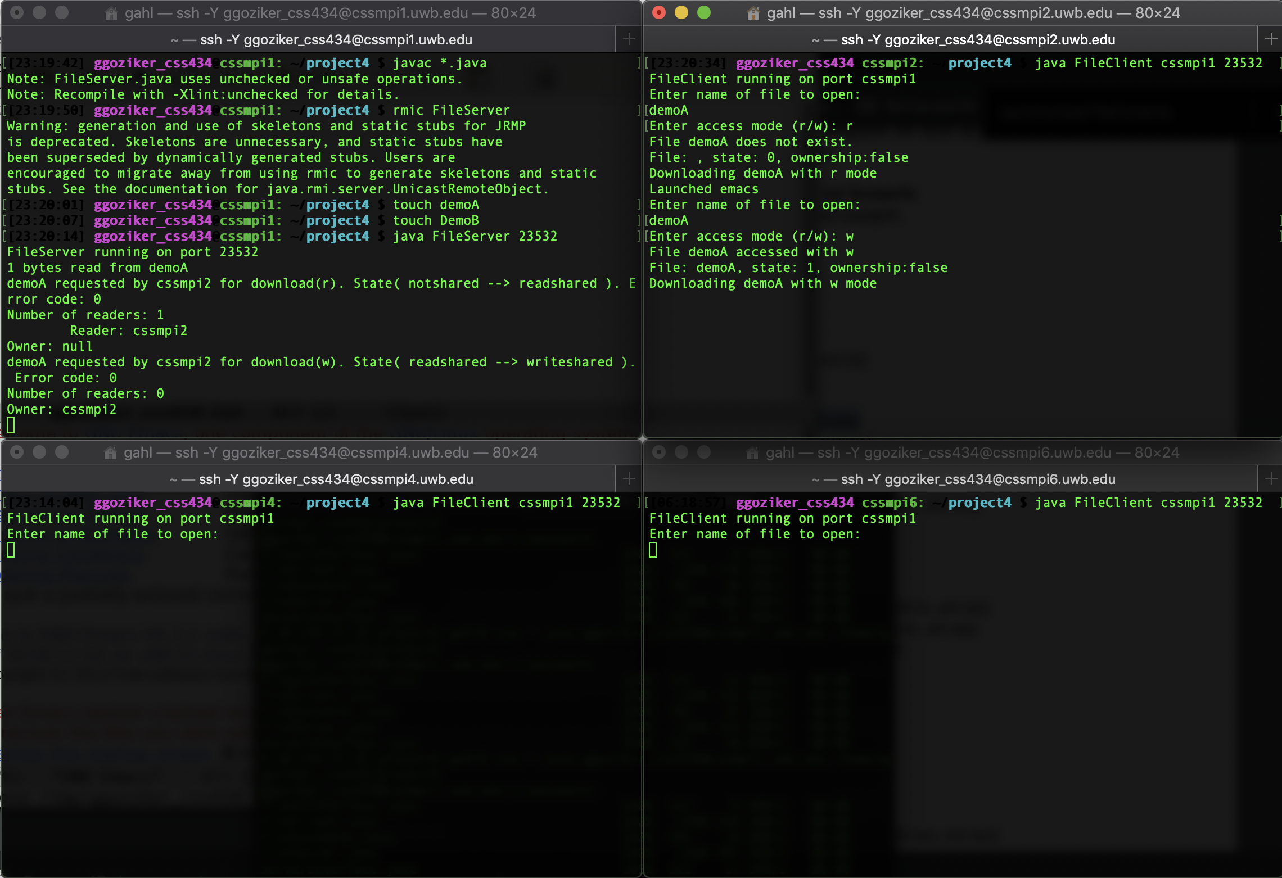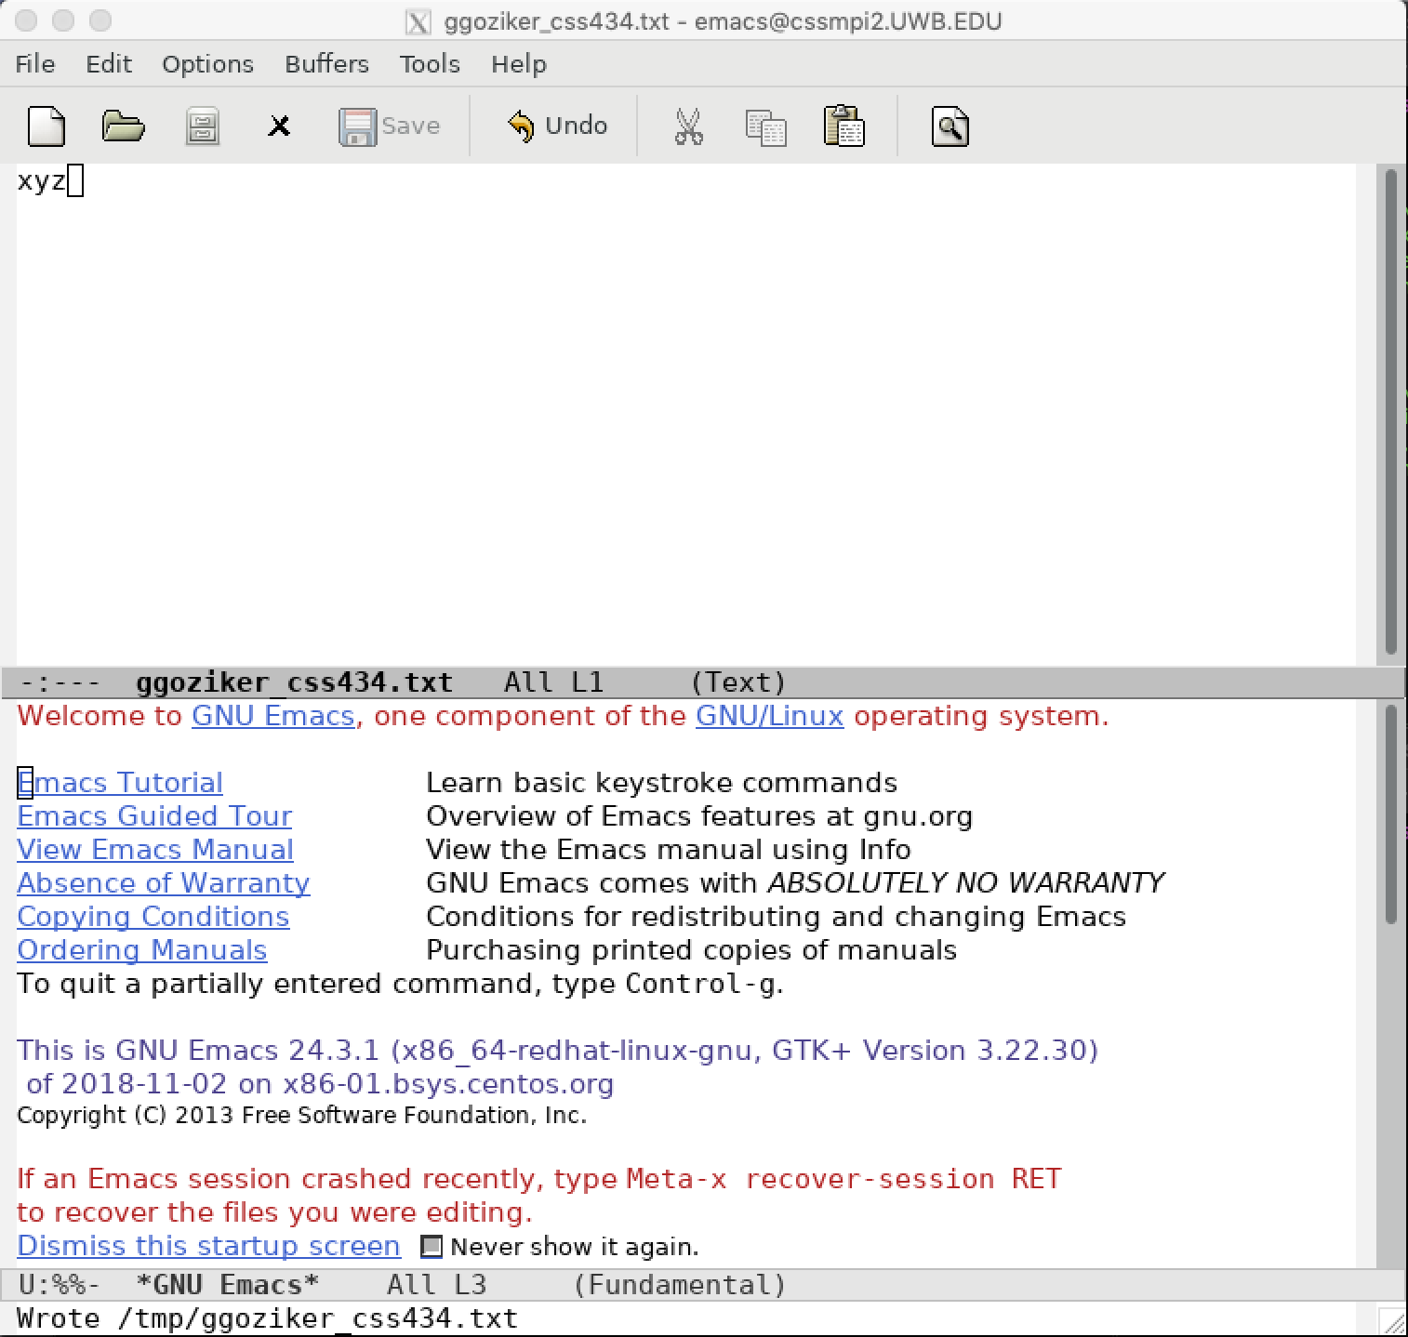

Step 7: Read xyz from demoA at cssmpi2. (A: clt:wo, svr:ws)

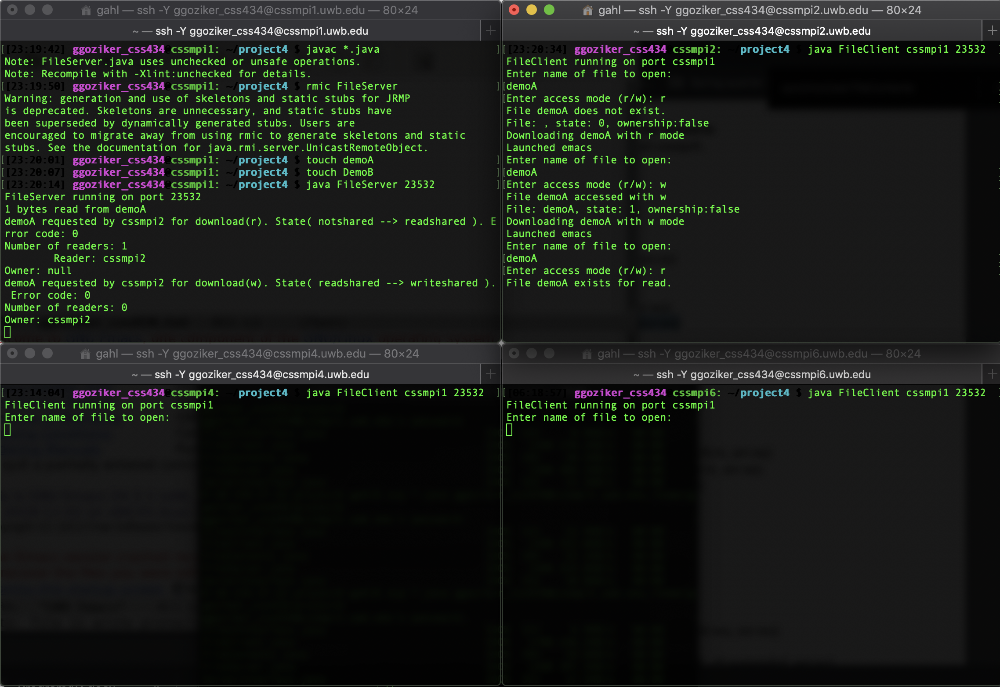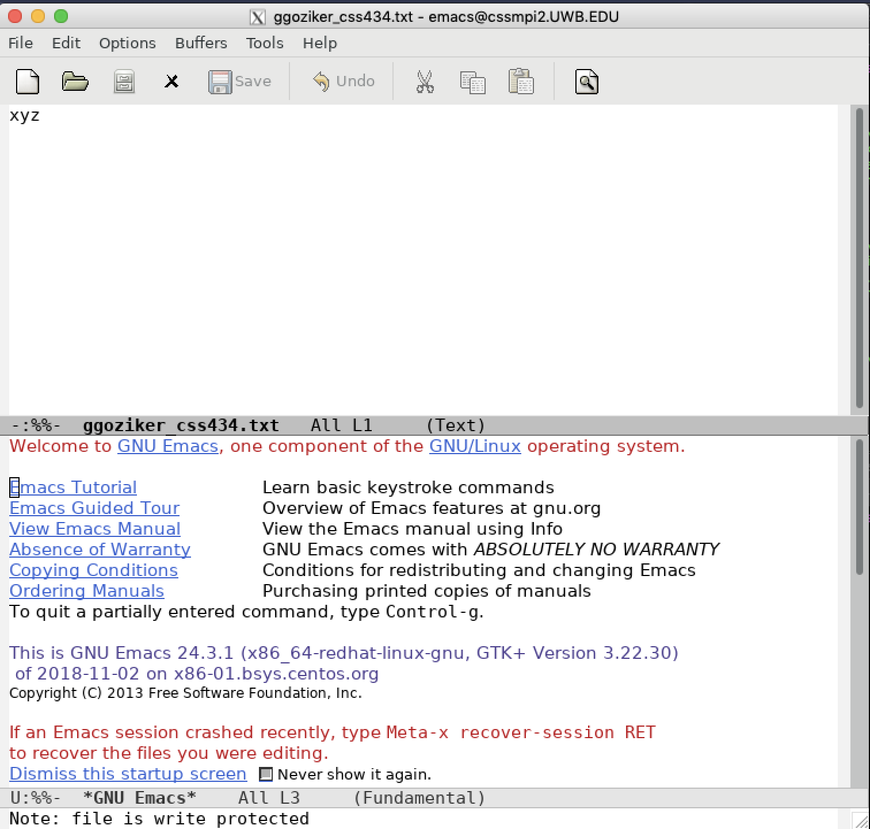

Step 8: Write 123 to demoB at cssmpi2. (A: clt:iv, svr:ns, B: clt:wo, svr:ws)

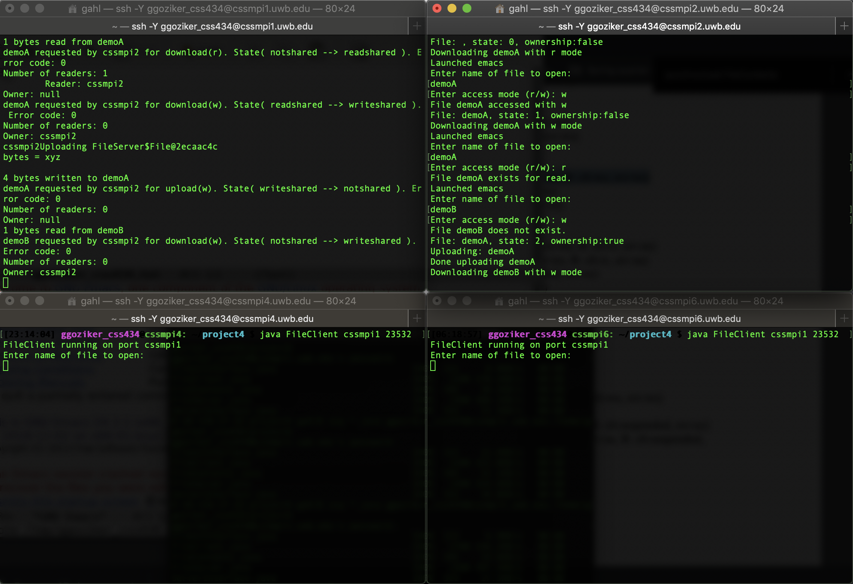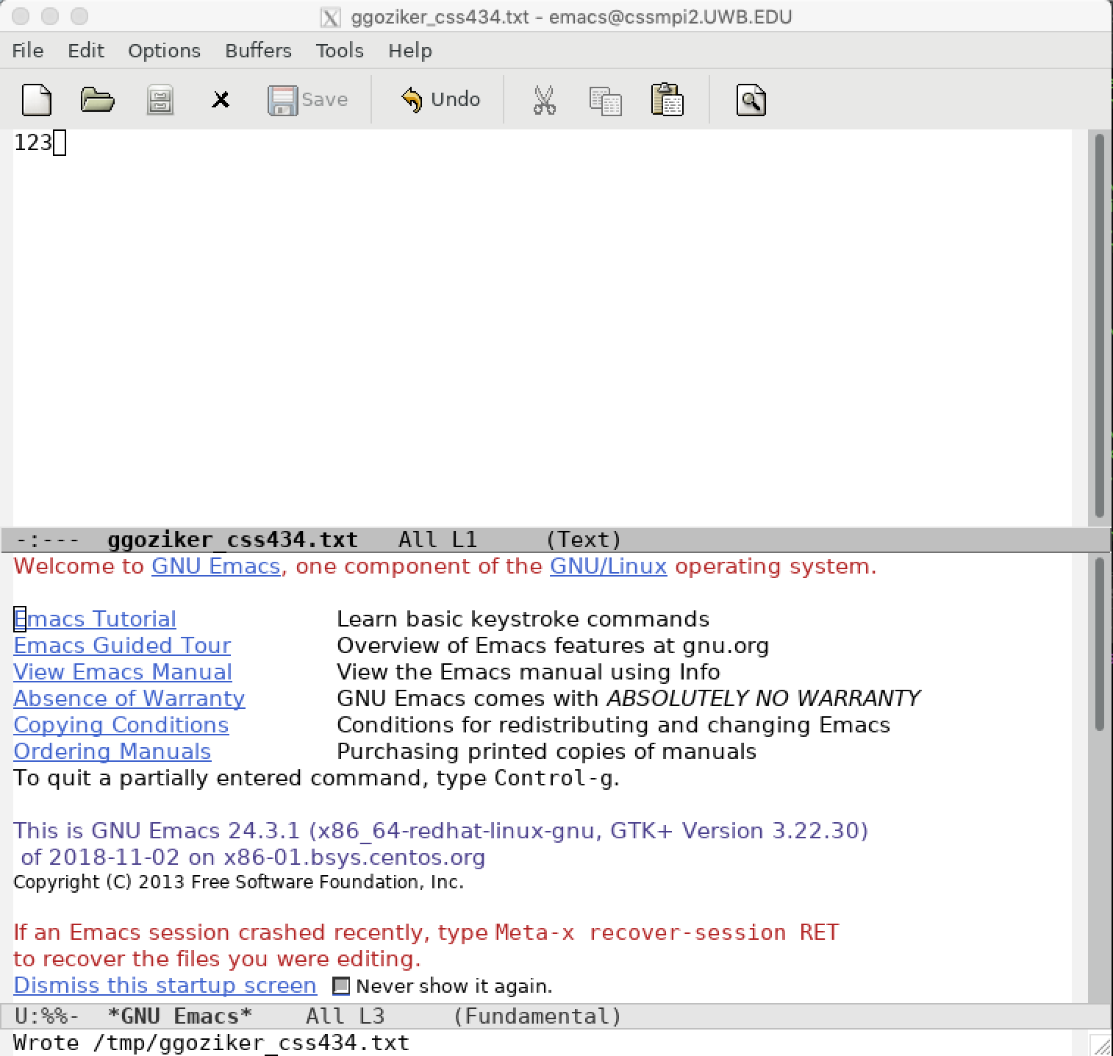

Step 9: Read xyz demoA at cssmpi4. (A: clt:rs, svr:rs)

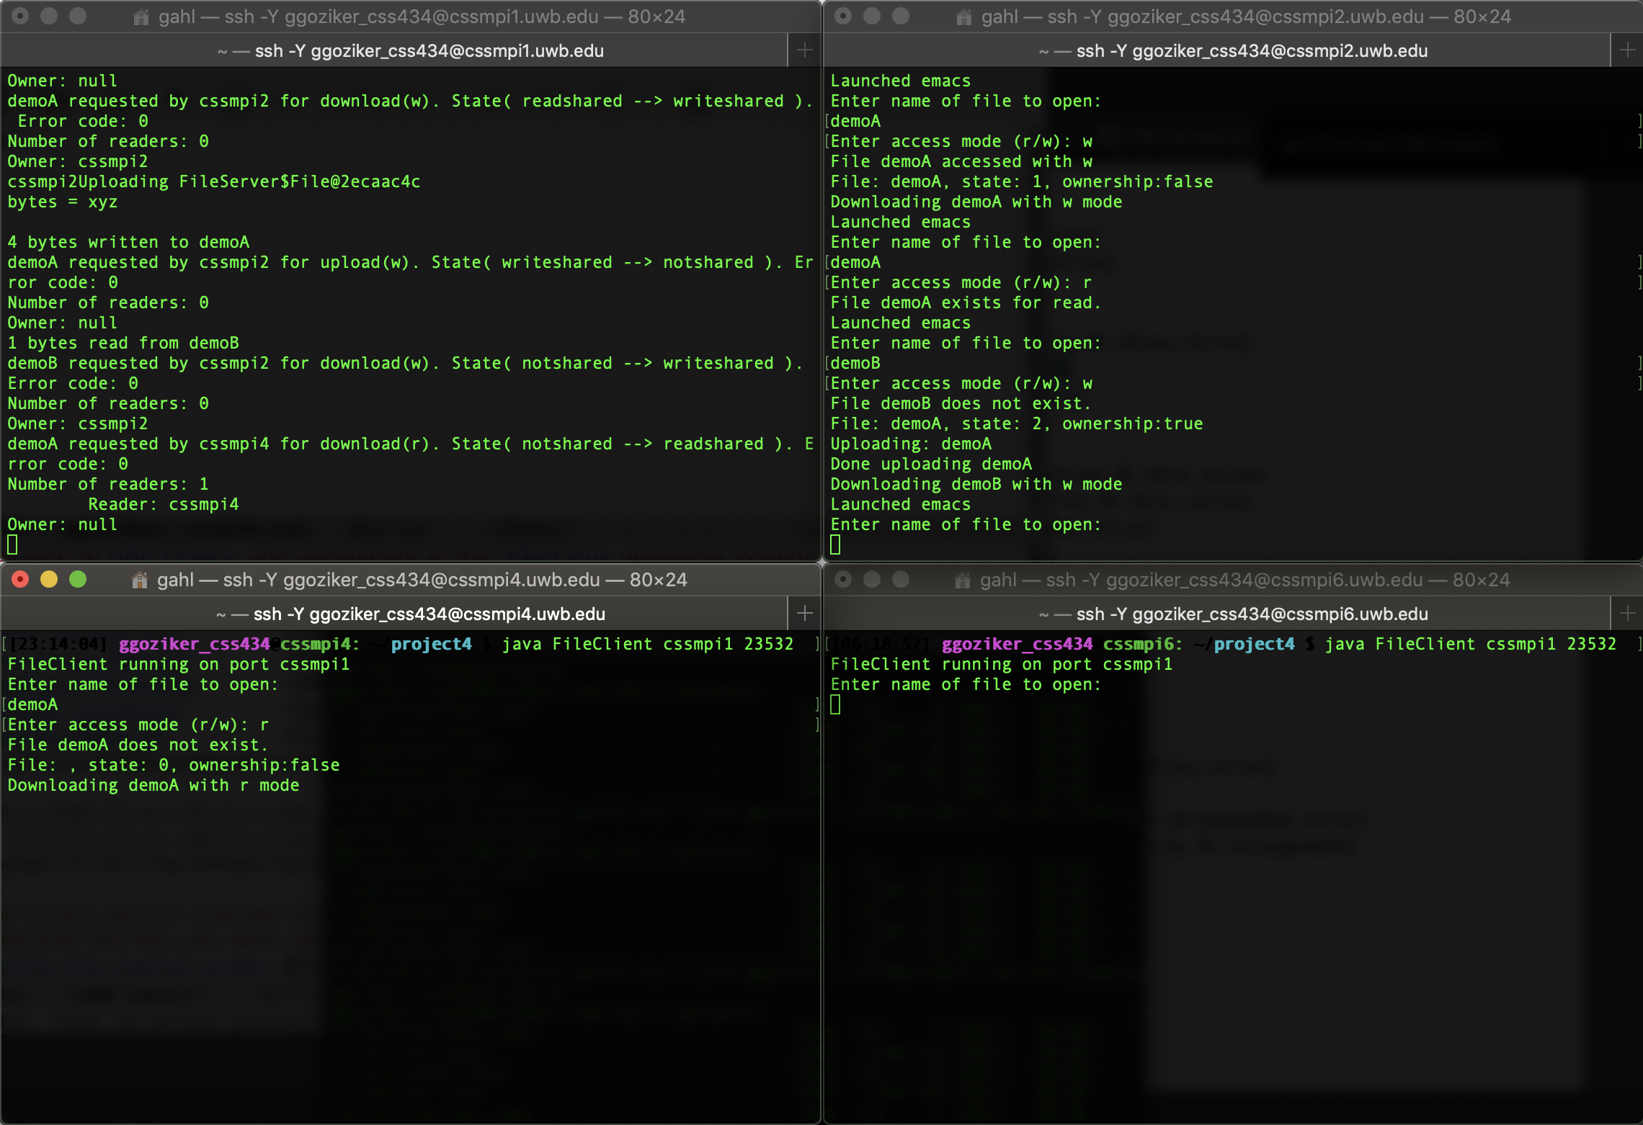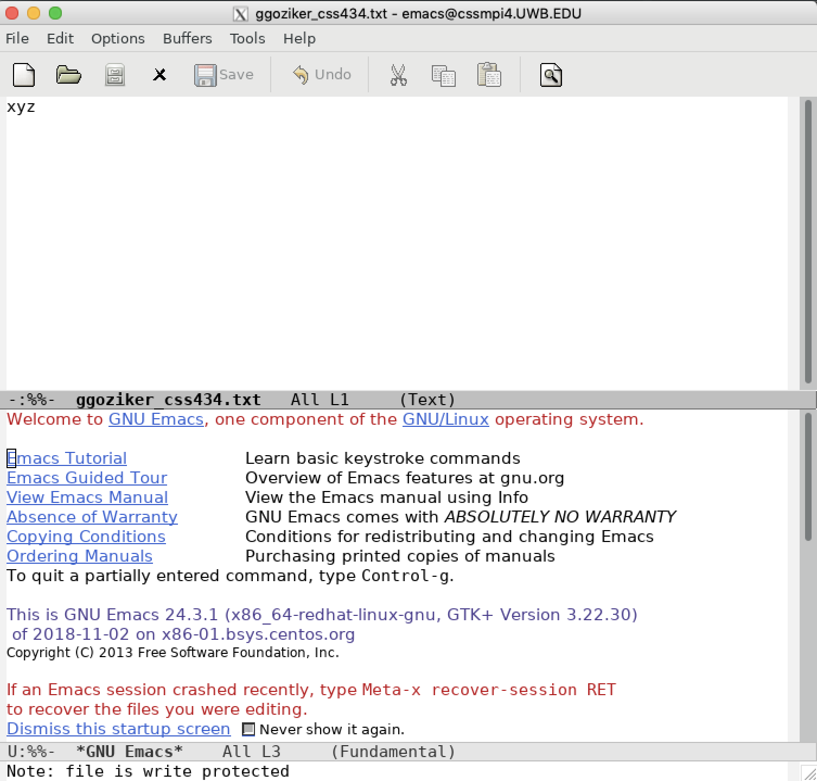

Step 10: Read xyz demoA at cssmpi8. (A: clt:rs, svr:rs)

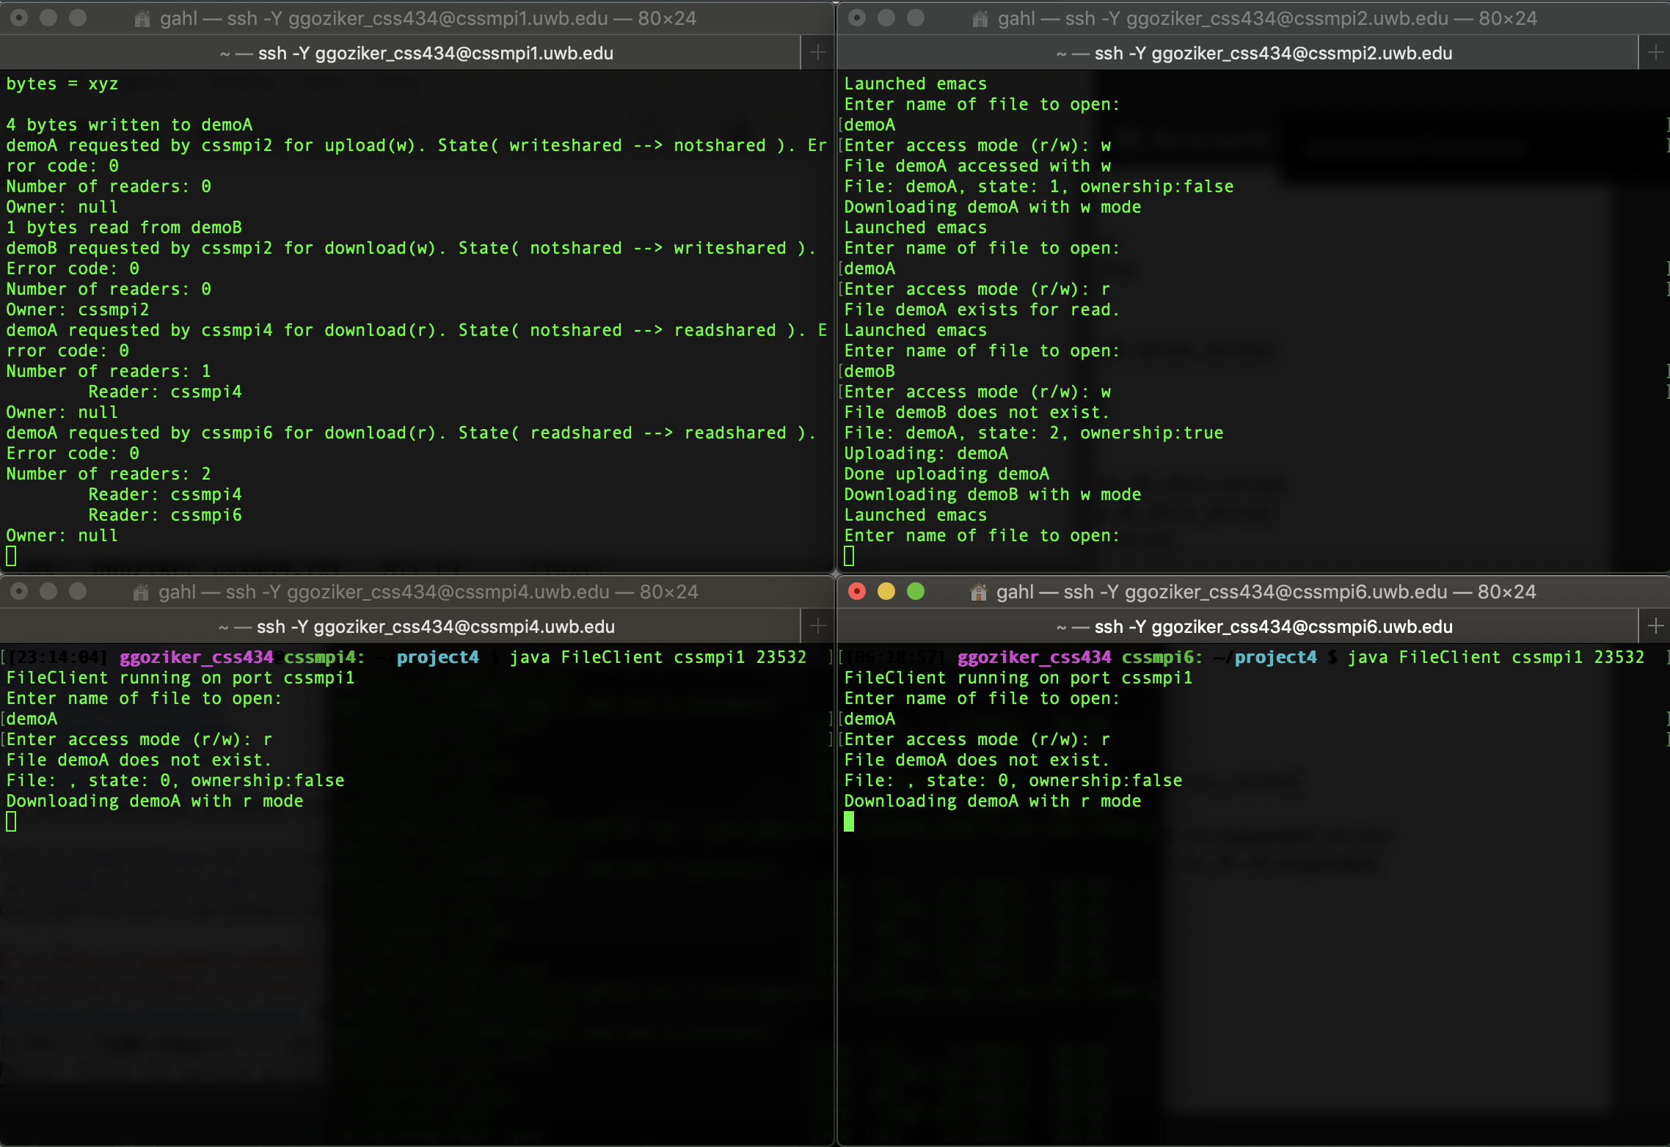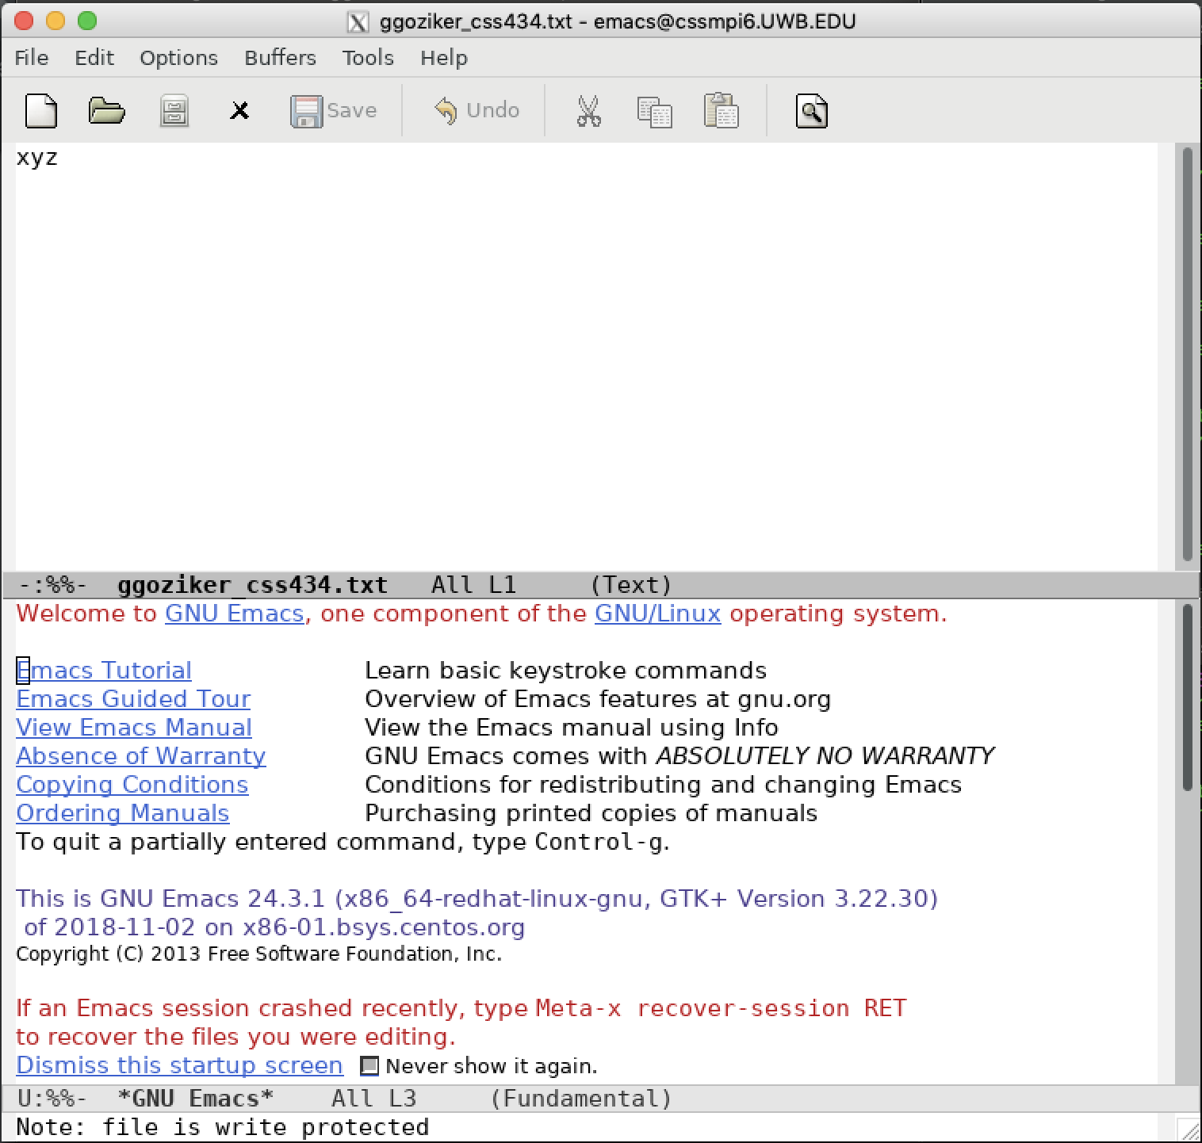

Step 11: Write xyz?! to demoA at cssmpi2. (A: clt:wo, svr:ws, B: clt:iv, srv:ns)

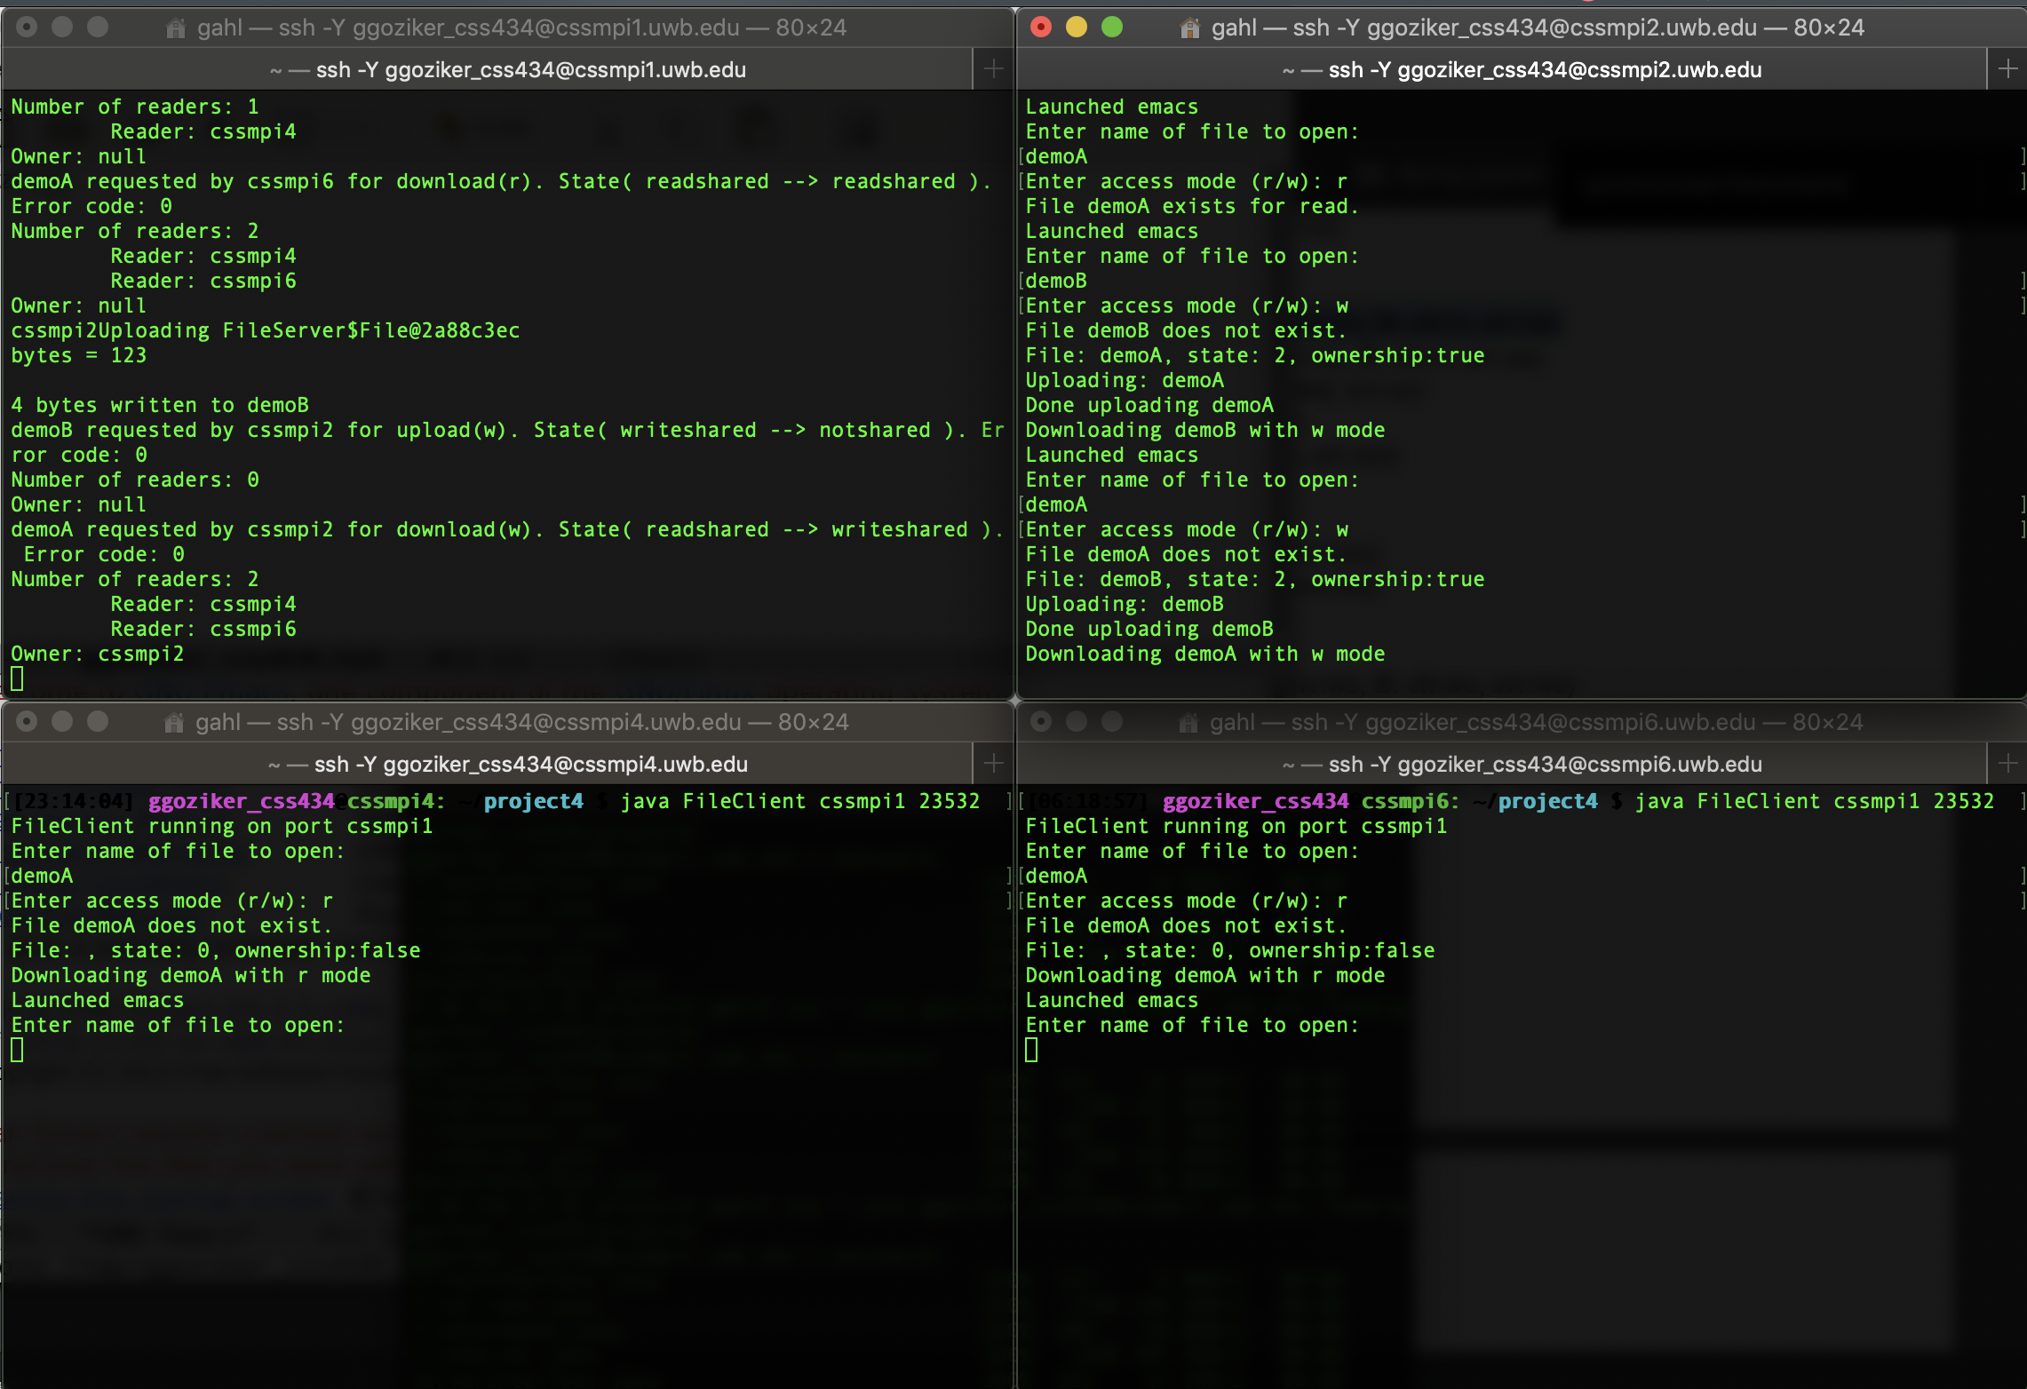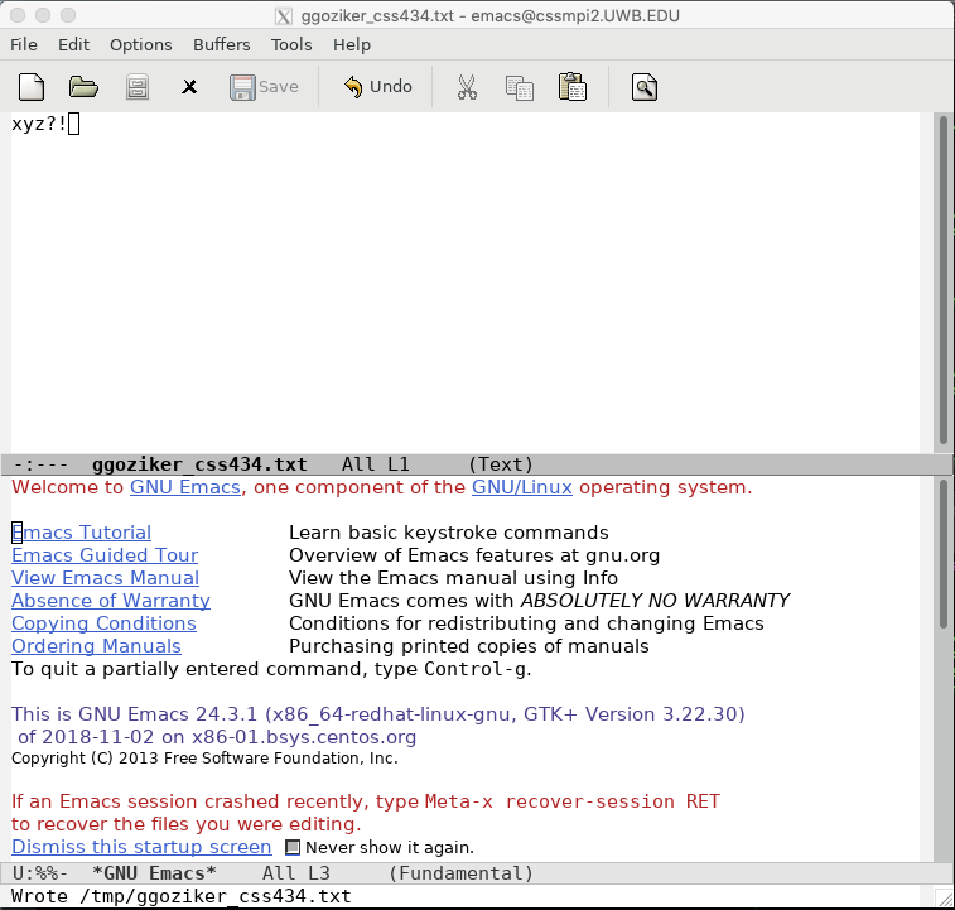

Step 13: Write to demoA at cssmpi4. (A: clt:suspended, svr:oc)

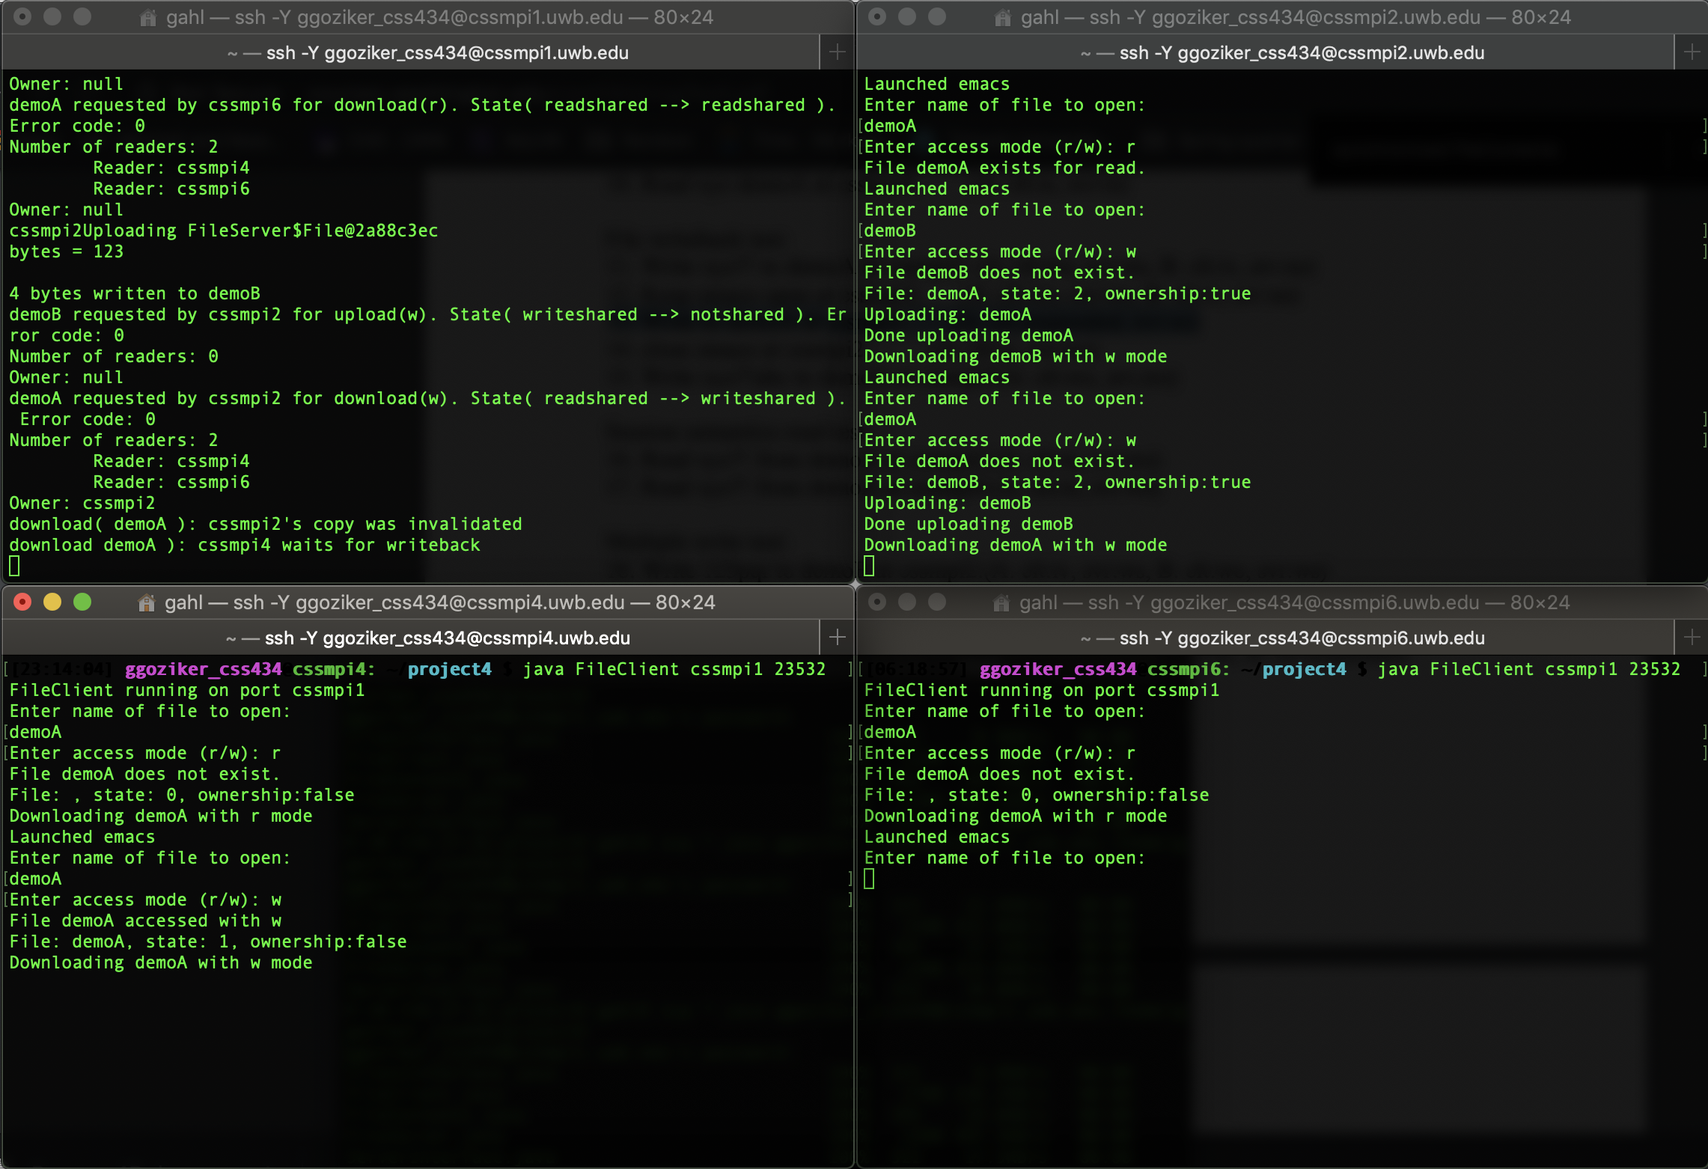

Step 14: close emacs at cssmpi2. (A: clt:rs, svr:ws)

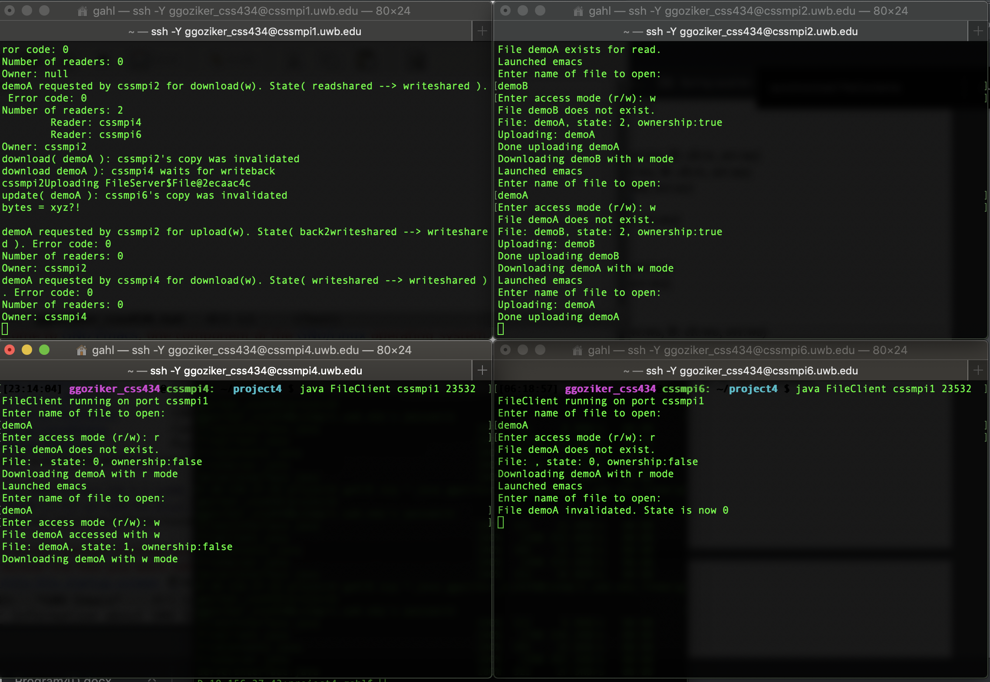

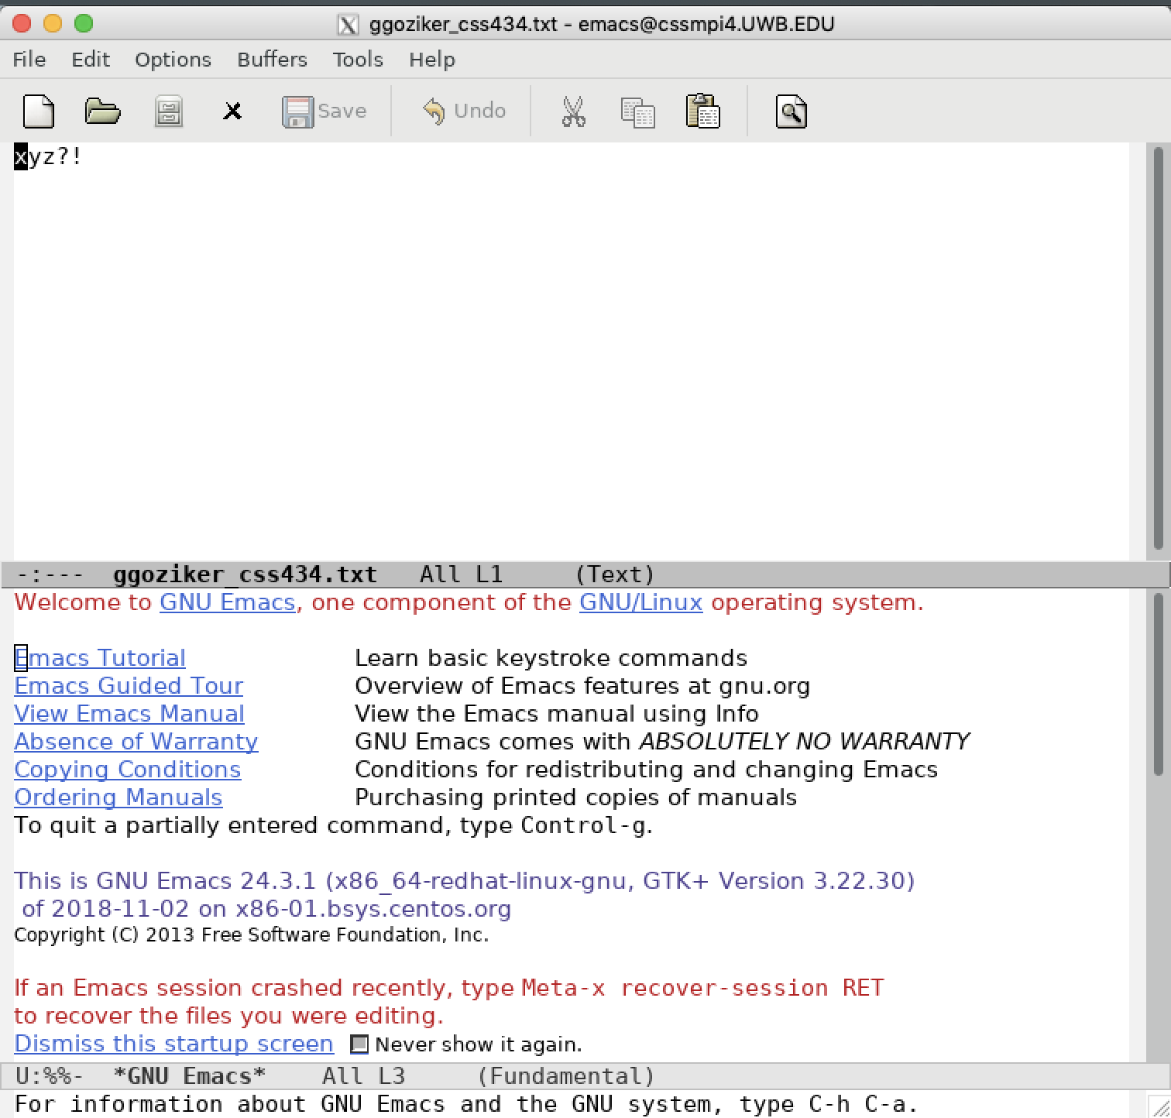

Step 15: Write xyz?!abc to demoA at cssmpi4(A: clt:wo, srv;ws)

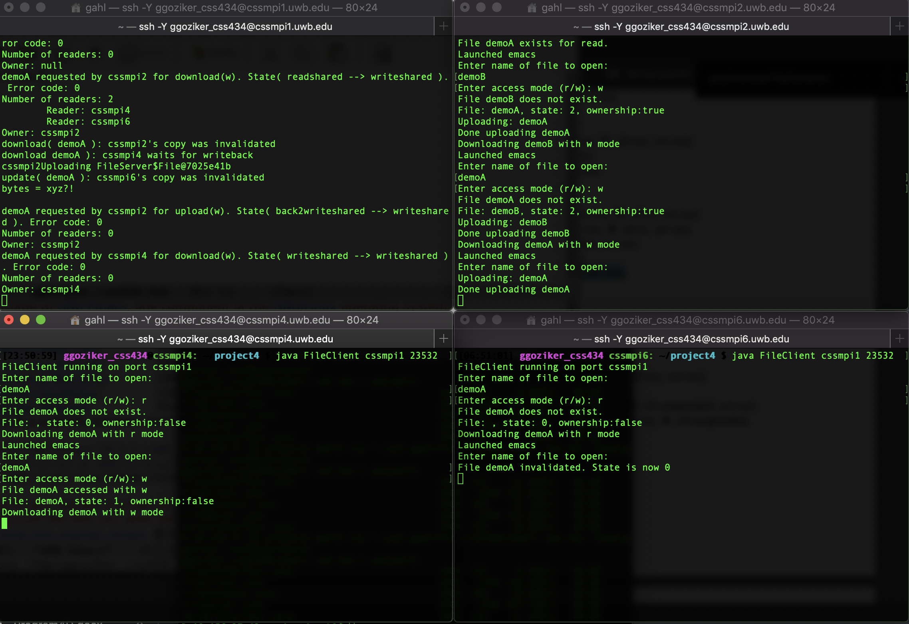

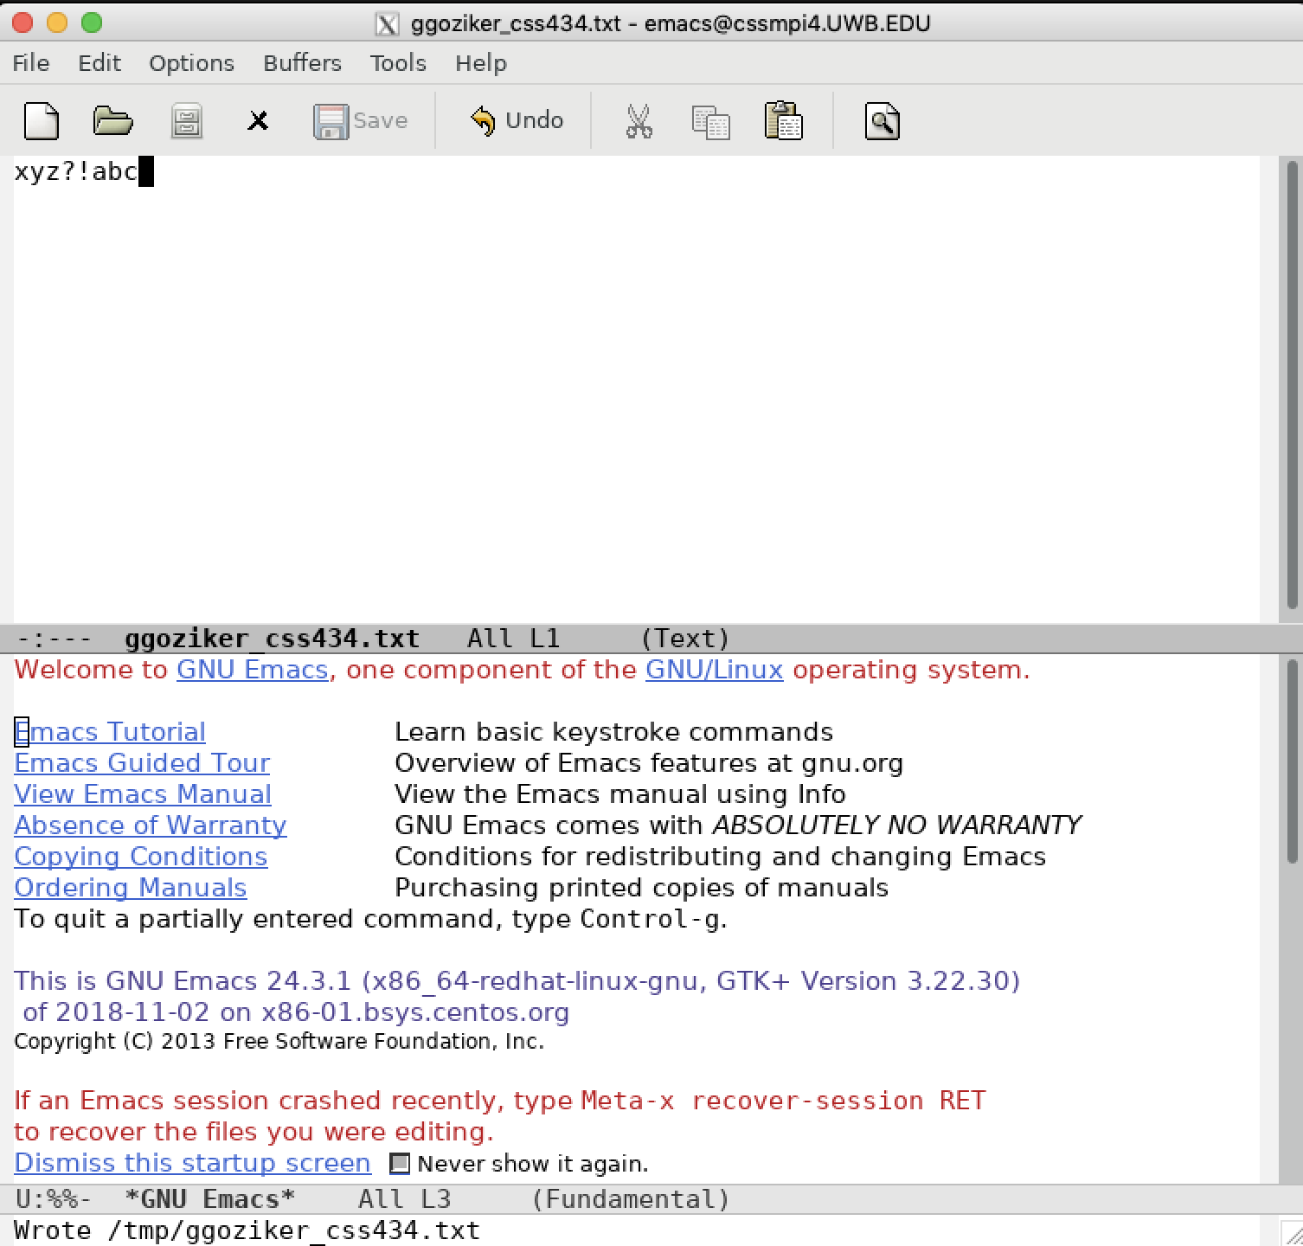

Step 16: Read xyz?! from demoA at cssmpi2.(A: clt:rs, svr:ws)

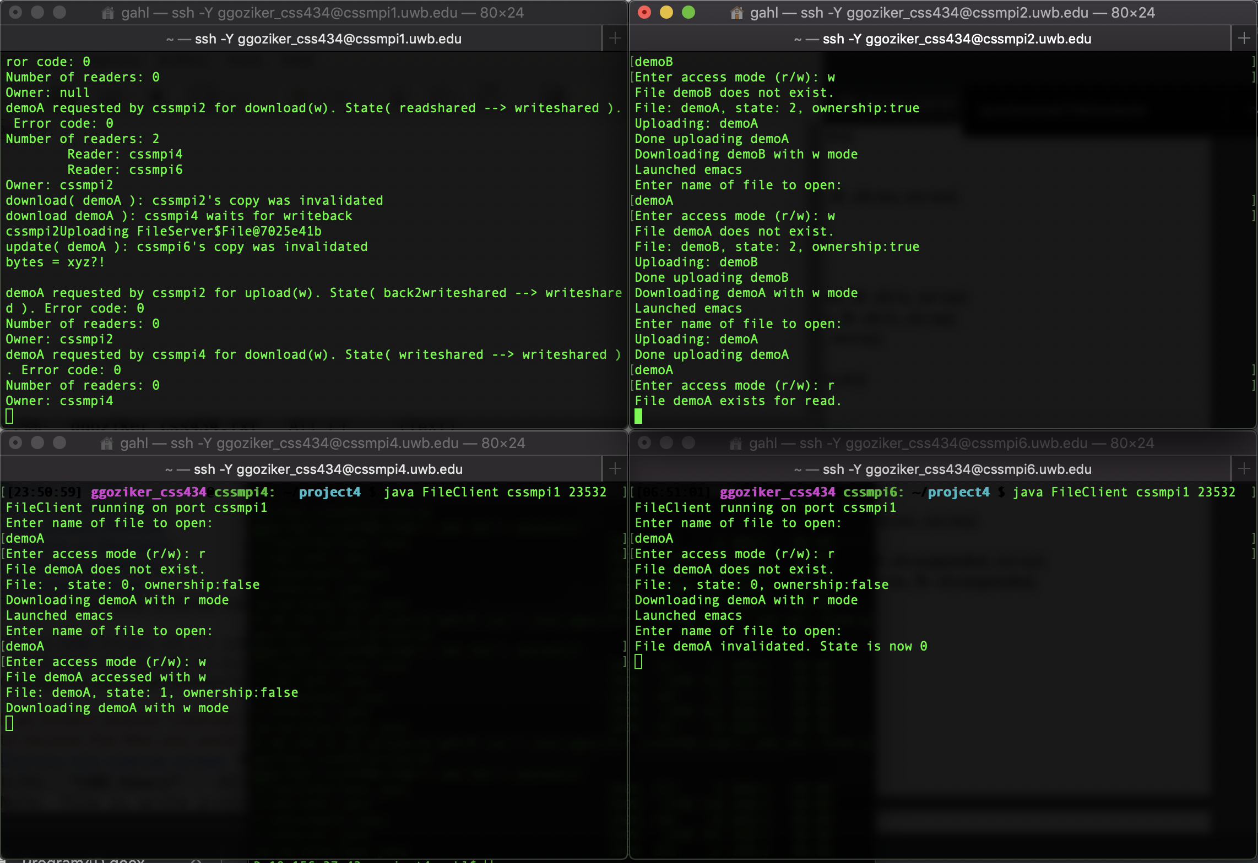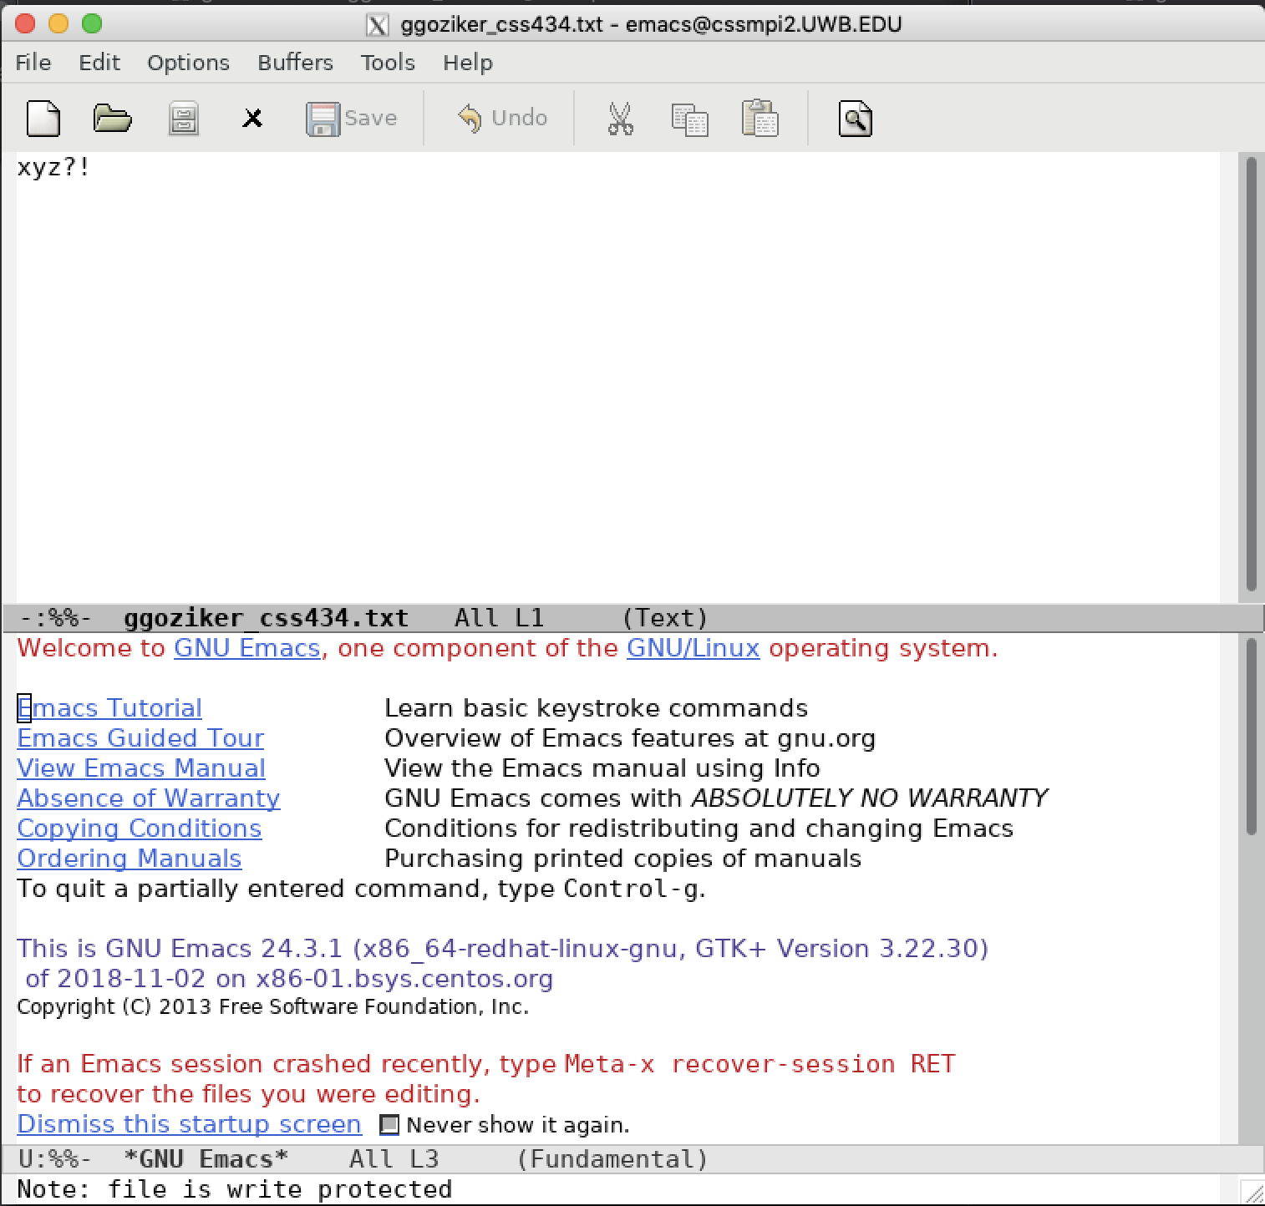

Step 17: Read xyz?! from demoA at cssmpi8.(A: clt:rs, svr:ws)

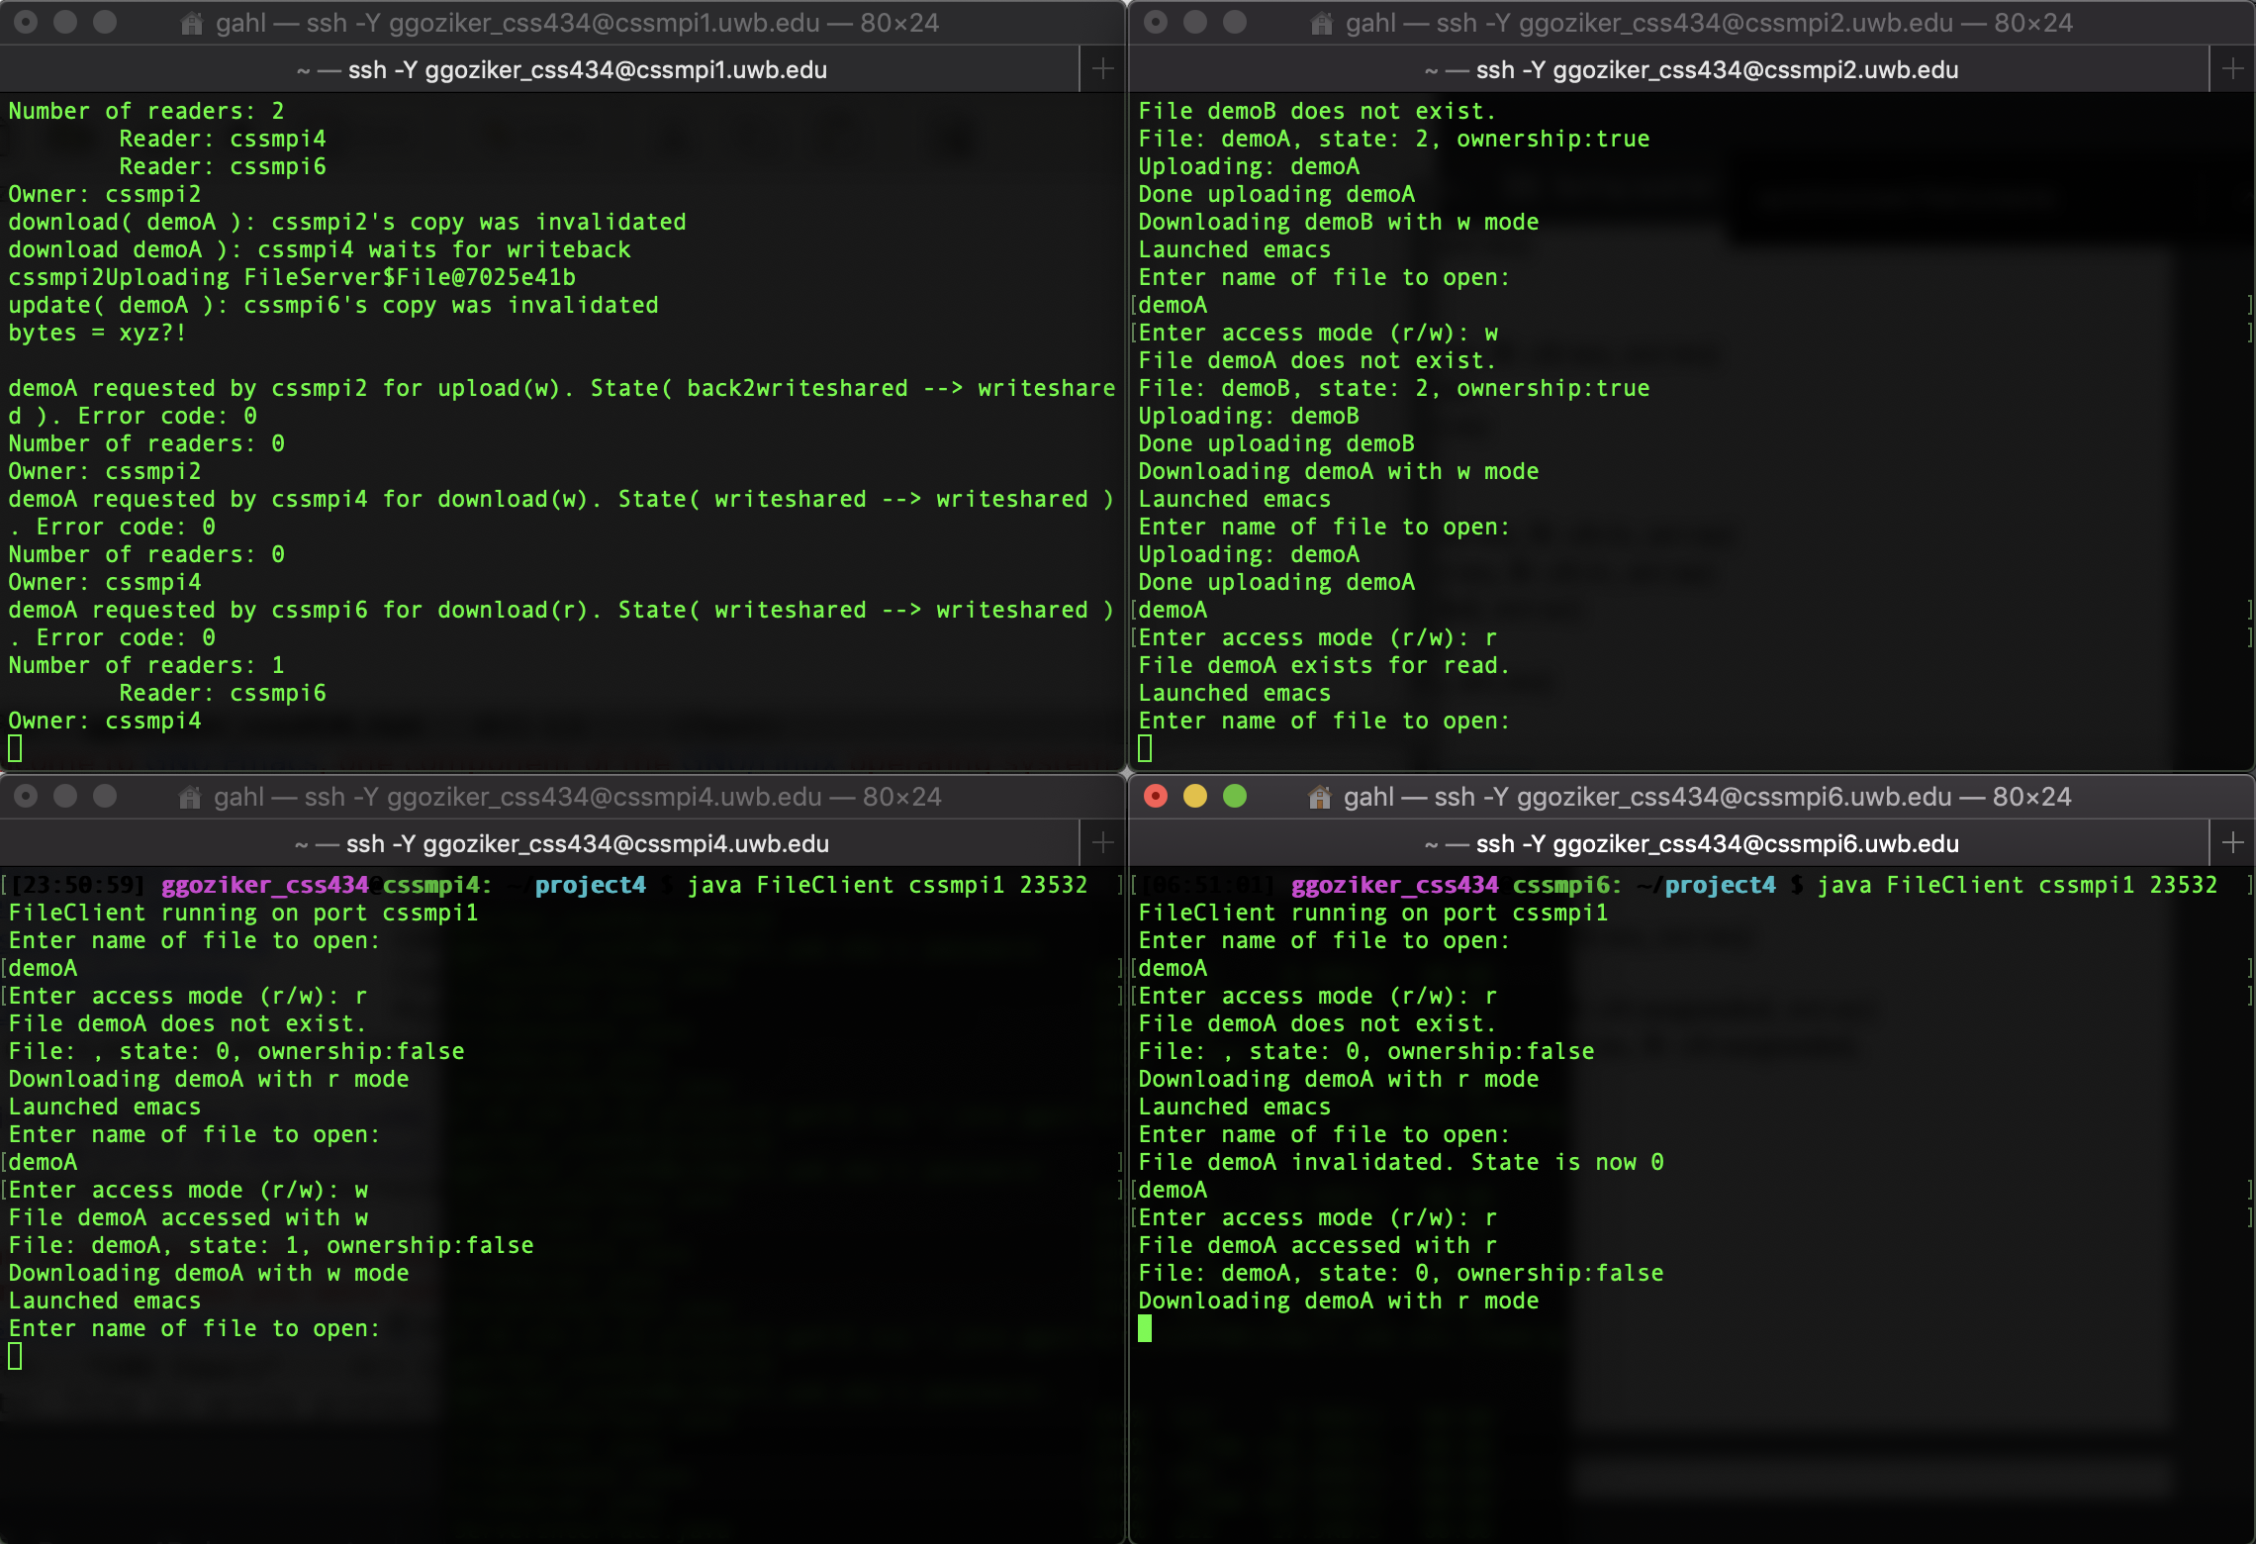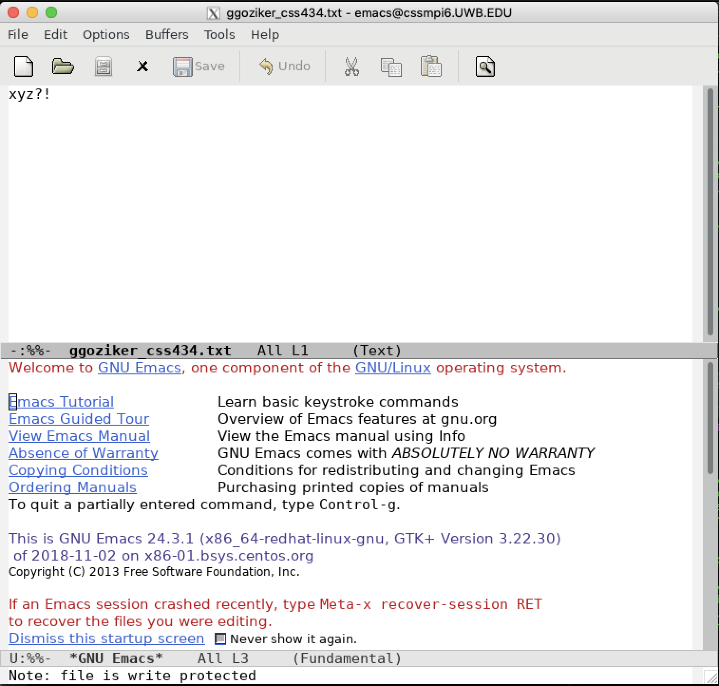

Step 18: Write 123pqr to demoB at cssmpi2.(A: clt:iv, svr:ws, B: clt:wo, svr:ws)

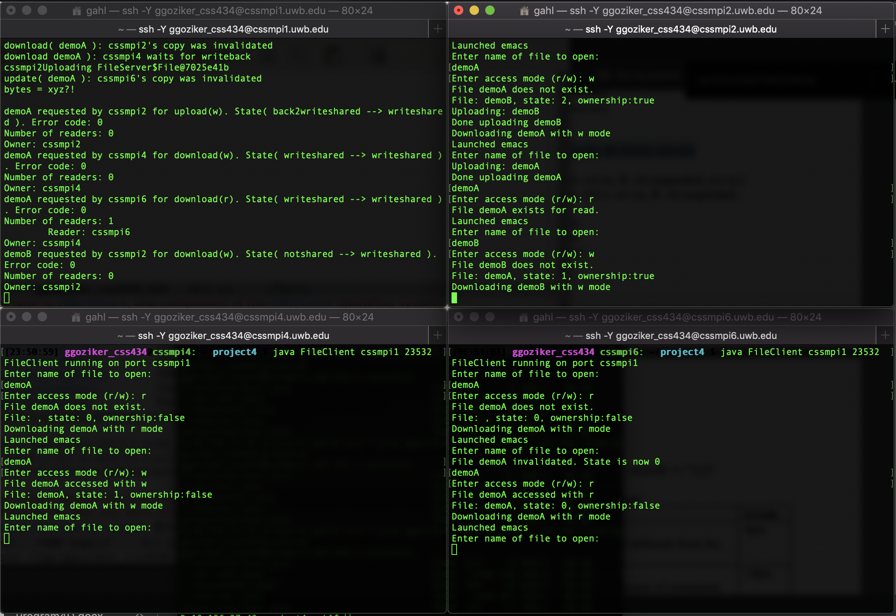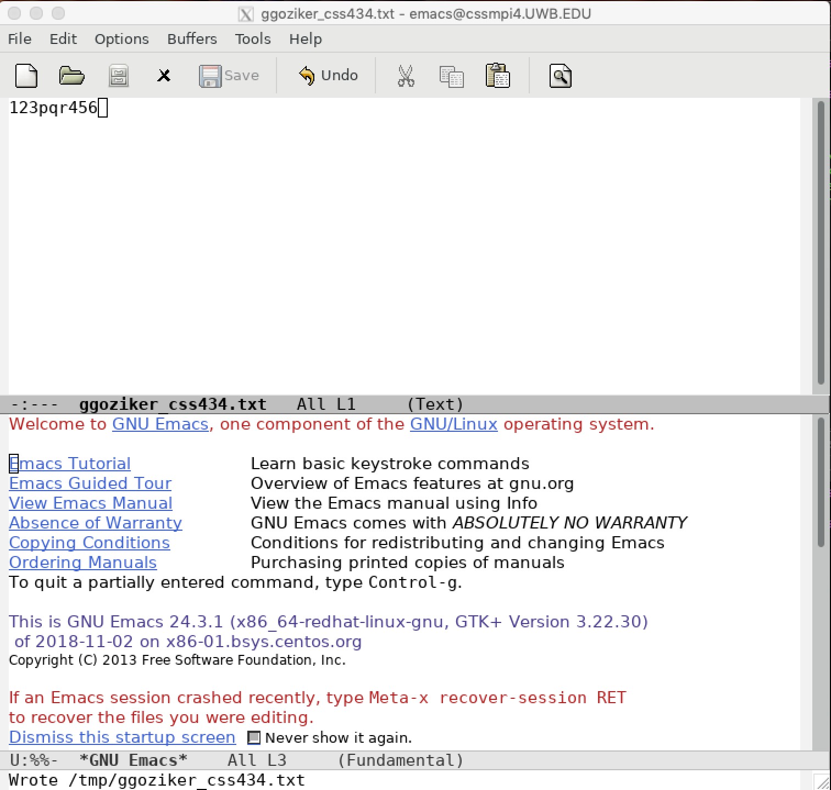

Step 20: Write 123pqr456 to demoB at cssmpi4.(A: clt:iv, svr:rs, B: clt:suspended, svr:oc)

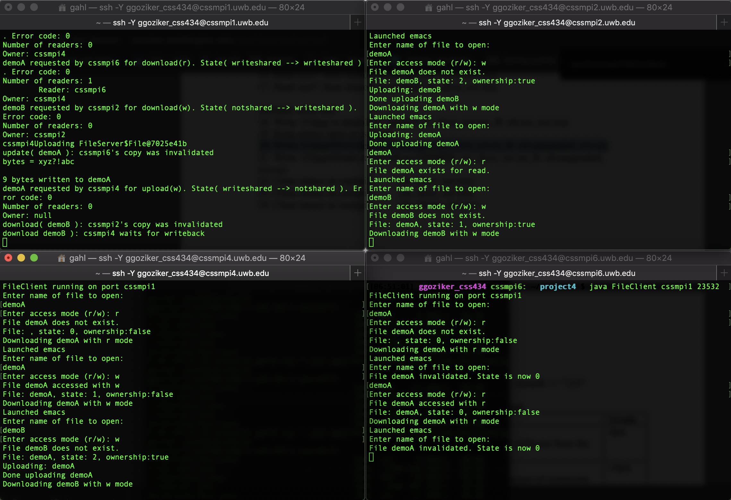

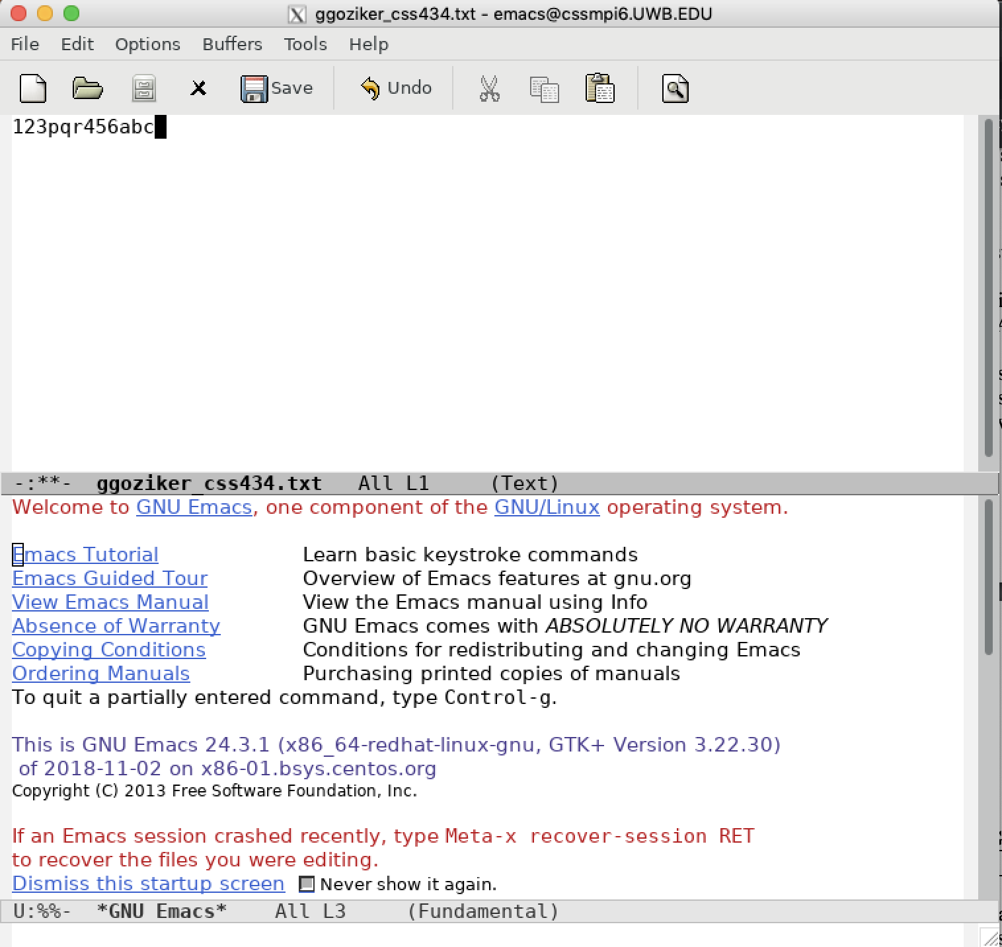

Step 21: Write 123pqr456abc to demoB at CSSMPI8. (A: clt:iv, srv:ns, B: clt:suspended,

svr:oc)

